Slippery Rock University
Student Counseling Center
Off Campus Referral Information and
Insurance Information

Referral Guide for Off-Campus Psychological Services:
You have been provided with a referral to private care off-campus. This document is intended to guide you in the process of getting connected to the mental health services you need. The Student Counseling Center strives to facilitate the total development of students by reducing psychological problems and distress and by enhancing mental health, well-being, quality of life, and supporting aspirations for optimal functioning. Our primary focus is on providing brief, confidential counseling aimed at helping students to succeed academically and interpersonally. Slippery Rock University’s Counseling Center offers services that include: professional assessment, consultation, crisis support/intervention, short-term counseling, and referral services. When students require mental health services that are beyond the role and scope of the SCC, we will make appropriate referrals to campus and community resources. Your private insurance can help you cover the cost of such care.
Making the First Contact:
Typically, you will be provided a phone number or possibly an email address to contact the outside provider/therapist. If you cannot speak with the contact person directly, try not to get discouraged. Leave a voice message identifying yourself, saying who referred you and when and how you can be reached. The provider will call you back usually within a day or so unless you indicate that you need an urgent contact. When you make contact, in addition to setting up a time to meet, you may ask additional questions. Depending on your needs and situation you may ask a potential provider any of the following:
1. “My concerns have to do with anxiety/depression/eating issues/alcohol issues/relationship/etc. problems and I am looking for a therapist/psychiatrist. Do you have experience working with these concerns?”
2. “What is your approach to working with these issues?”
3. “Where exactly is your office? Is it accessible via public transportation?”
4. “I have XX insurance. Are you a provider in my network or will you be an out of network provider? What are your fees and payment policies?”
5. “I do not have insurance coverage. Do you offer any discounts or other fee arrangements like sliding scale for students?”

Private Insurance:
If you have insurance coverage, you must determine your policy’s requirements by contacting your insurer directly. If you are on your parent’s plan, you may have to speak with your parents to gain access to your insurance. You may also find information about coverage on the insurance provider website. When using insurance, you may want to ask your insurance company the following questions:
• Do I have mental health benefits?
• What is the yearly deductible?
• What do the benefits cover?
• How can I find an in-network provider?
• Do I have an out-of-network benefit? What is it?
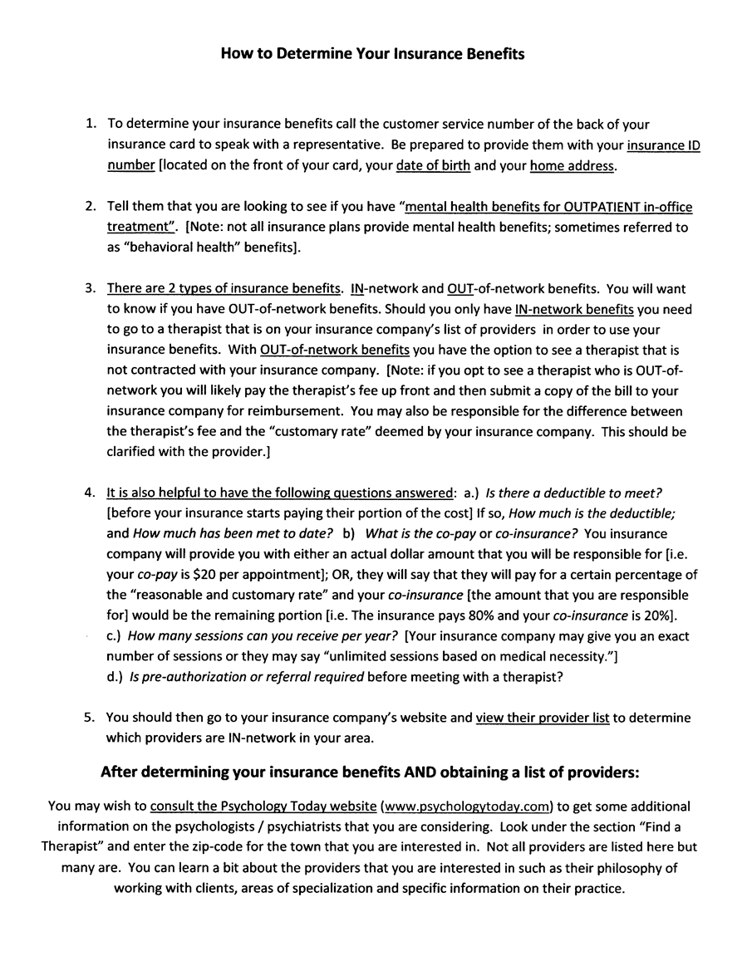
FAQs – Frequently Asked Questions:
Will my health insurance pay for off-campus care?
Health insurance, a private plan, can often help with the cost of off-campus psychological services. The best source for information about your coverage and benefits is your particular insurer.
Why can’t I see a clinician/psychiatrist on campus?
The Counseling Center provides short-term care to students in part due to the volume of students served. For ongoing or specialized care or access to services not available at The Counseling Center (e.g., specialized care, hospitalization, etc.) we refer our students into the community. Even though students may feel that ongoing counseling on campus would be more convenient, your mental health support may need to be more specialized, extensive, or frequently available than the services provided on campus, and therefore may be better served by off-campus providers who are set up for those services.
Why do some students prefer off-campus care?
Students may prefer to go off campus rather than see a counselor at the Counseling Center for numerous reasons. For some, it can feel more private to have your own therapist off campus; for others the possibility of a wider choice among off campus providers is appealing. Sometimes, students get referrals to community providers from their therapists and psychiatrists at home. Some students may find the schedules of private practitioners or other mental health centers, who may offer evening and weekend appointments, more convenient. Finally, some services simply are not available at the Counseling Center, such as neurological services, drug detoxification/treatment, etc.
What if I don’t like the person you refer me to?
The Counseling Center has a list of clinicians and clinics in this area who have experience providing good mental health care for university students. However, the right match between clinician and students can also be very important in contributing to effectiveness of treatment and care. We cannot guarantee the match and quality of care students receive from private providers and it is important for you to make a choice that works for you. Sometimes, the first provider you meet is the right one for you, but at other times this is not the case. In most cases, the Counseling Center therapist who provided the referral most likely has given you a number of providers to contact, so please try to contact others on the list if the first one does not work out. If you feel you have not found a good match, do not hesitate to contact your referring Counseling Center therapist and he/she will help you with your next steps including providing other referrals.
If you have any additional questions or concerns and/or need help in any way, please contact the Slippery Rock University Counseling Center clinician who referred you and they will be happy to help.
For questions about off-campus psychological care or the referral process please call The Counseling Center at (724) 738-2034.

