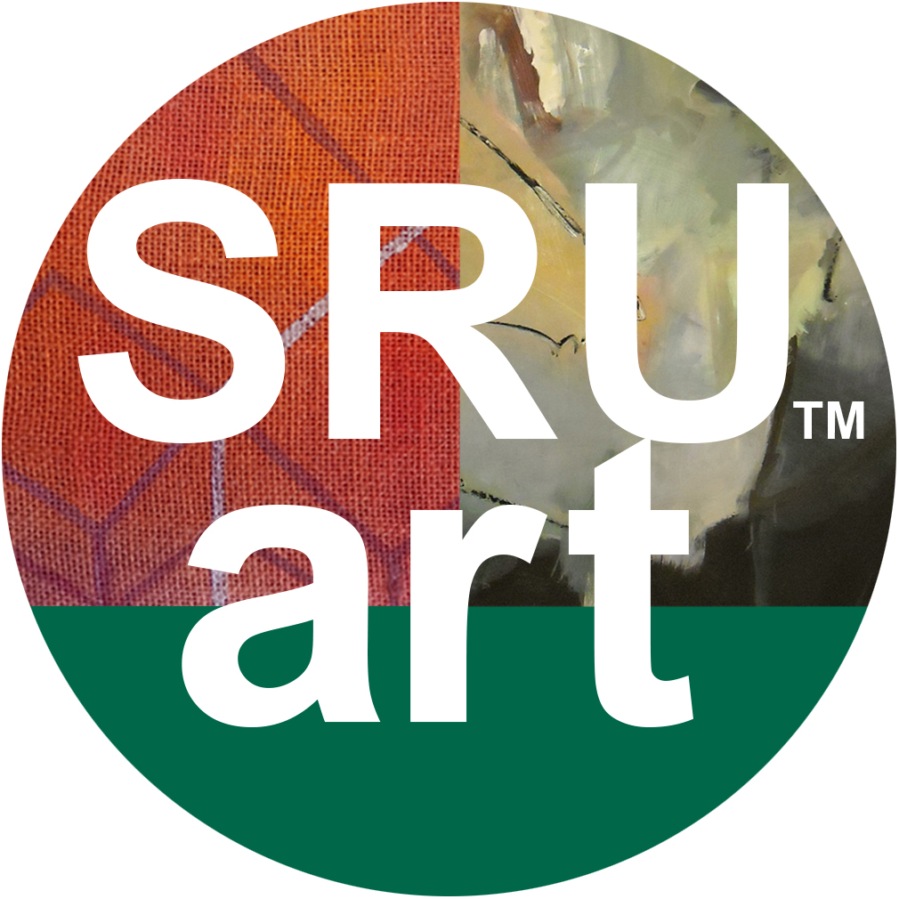

ART DEPARTMENT SCHOLARSHIP APPLICATION
This scholarship application form is to be used by incoming ART MAJORS.
The applicant has to have the deposit paid at the time of this application and have a commitment to attend Slippery Rock University as an Art Major in Fall 2022. Complete this application carefully and email all materials to: slipperyrockartscholarships@gmail.com
Deadline: February 25, 2022

Name:___________________________________________________________________
Home address: ____________________________________________________________
Telephone:________________________________________________________________
SRU e-mail address: ________________________________________________________

I give Slippery Rock University permission to use information contained in my academic records and on my financial aid application during the review of my eligibility for scholarships. I understand that additional information may be requested from me for the application process.

Student signature: ____________________________ Date: ____________________________
PLEASE INCLUDE THE FOLLOWING:
- A completed Art Department Scholarship Application form.
- Portfolio: Power Point with 5 of your best works (any medium) saved as a .pdf document.
- Please submit a one-page essay describing the importance of studio art courses as a means of achieving academic and artistic goals.

Questions can be e-mailed to kurt.pitluga@sru.edu

