Module Two
OneNote and OneDrive Tips and Tricks

Tip One: Getting Started with OneNote
Step One: Click on the OneNote icon on the Office 365 homepage.
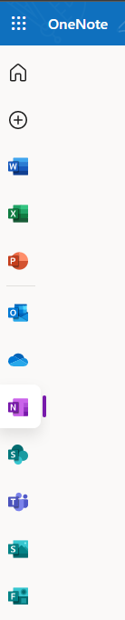

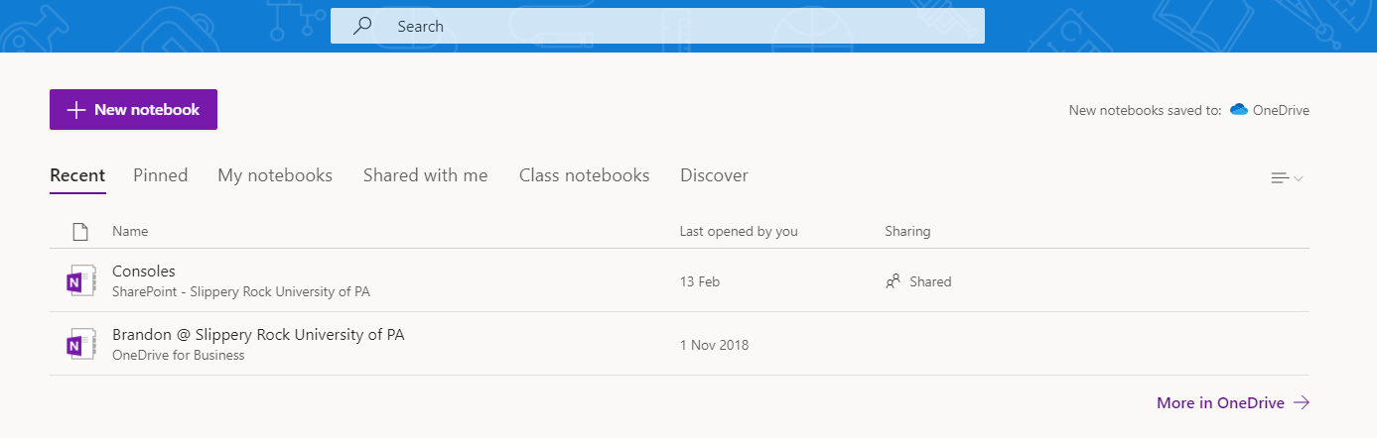
Step Two: On the home screen of Notes, you can create a new notebook. You can also view your pinned notebooks, view all notebooks, notebooks that have been shared with you, and class notebooks. Click on the purple new notebook icon to create a new notebook.
Step Three: Next, you will be prompted to name your new notebook.
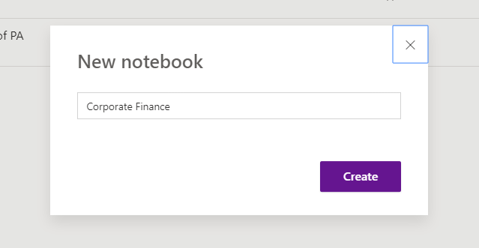

Step Four: Once the notebook is created (I created one specifically for my corporate finance class), you will have an empty notebook. You can add notes by clicking on the white space or by pressing “enter” on your keyboard. This will prompt you to enter a section title for your notebook. See step five for section titles.
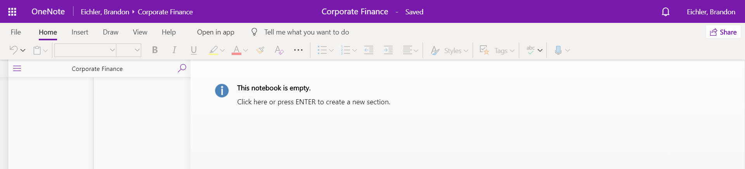

Step Five: After clicking on the white space or hitting enter, a window will pop up for you to name the section of your notebook. I named the section of my notebook the chapter title for the class, “Stock Options”.
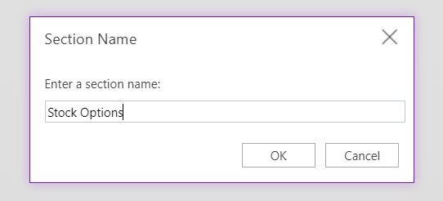

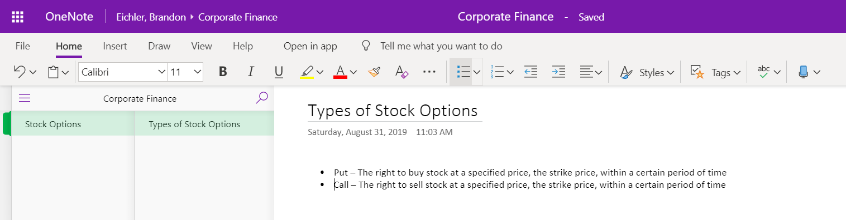
Step Six: After naming your section, you can then fill in your notebook with notes. There is similar functionality in OneNote as there is in Word such as creating bullet points, paragraph spacing, and selecting text color. Within my section of stock options, I named one page within that section “Types of Stock Options”.

Quick Tip: All Office 365 applications have an auto save functionality. So, as soon as you make changes they will be saved.

Step Seven: To create a new section or page, in the bottom left corner of OneNote you will see options to “+ Section” or “+ Page”.

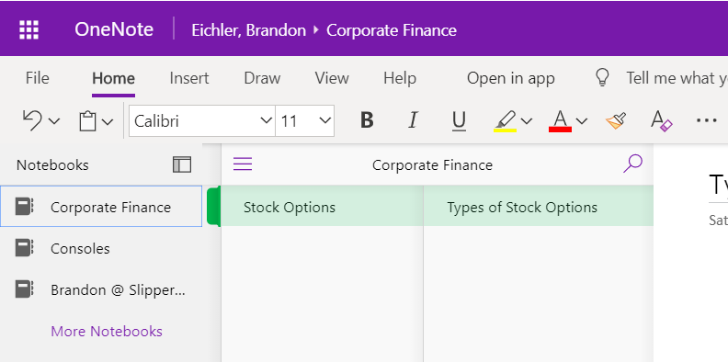
Step Eight: To view all notebooks or create a new notebook, click on the menu icon (the hamburger) to expand the notebook column. To add a new notebook, at the bottom of the column, click on “+ notebook”.

Tip Two: Some Keyboard shortcuts in OneNote
OneNote Shortcuts
Ctrl + / | Insert a numbered list
Alt + Shift + → or ← | Inserts an indent or outdent
Ctrl + A | Selects everything on the page
Ctrl + B or U or I | Either bold, underline, italics

Tip Two: Drawing on a OneNote Page
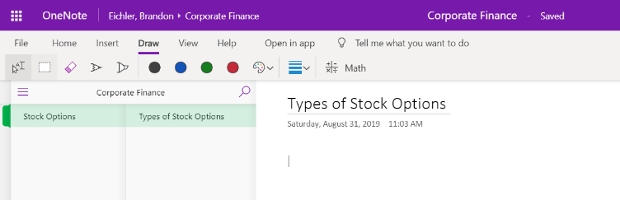
Step One: Once you are in the section you want to add a drawing to, click on the draw tab and then you can choose from a pen, highlighter, choose your color, and depth.

Tip Three: Add Tags to a OneNote
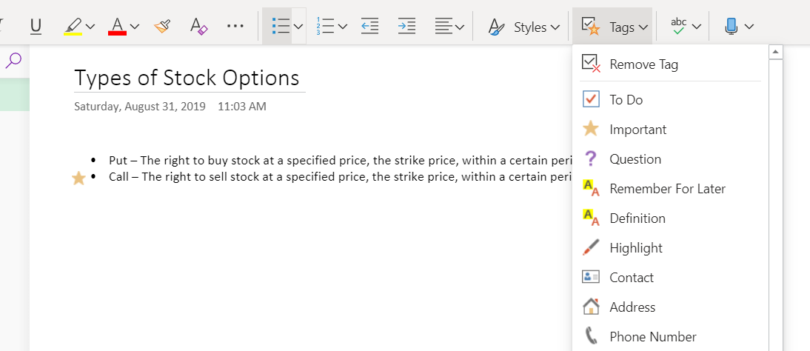
Step One: If you go to the home tab there is a section called “Tags”. In this section you are able to add different tags to the page you are working on. With tags, you can quickly return to important items, remind yourself about action items, or filter on notes you'd like to share with others.

Tip Four: Saving documents to OneDrive

Step One: In any Office application, click on file and then save as, there will be an option to save it to your OneDrive account. Once the file has been saved you can access it from anywhere you have an internet connection.
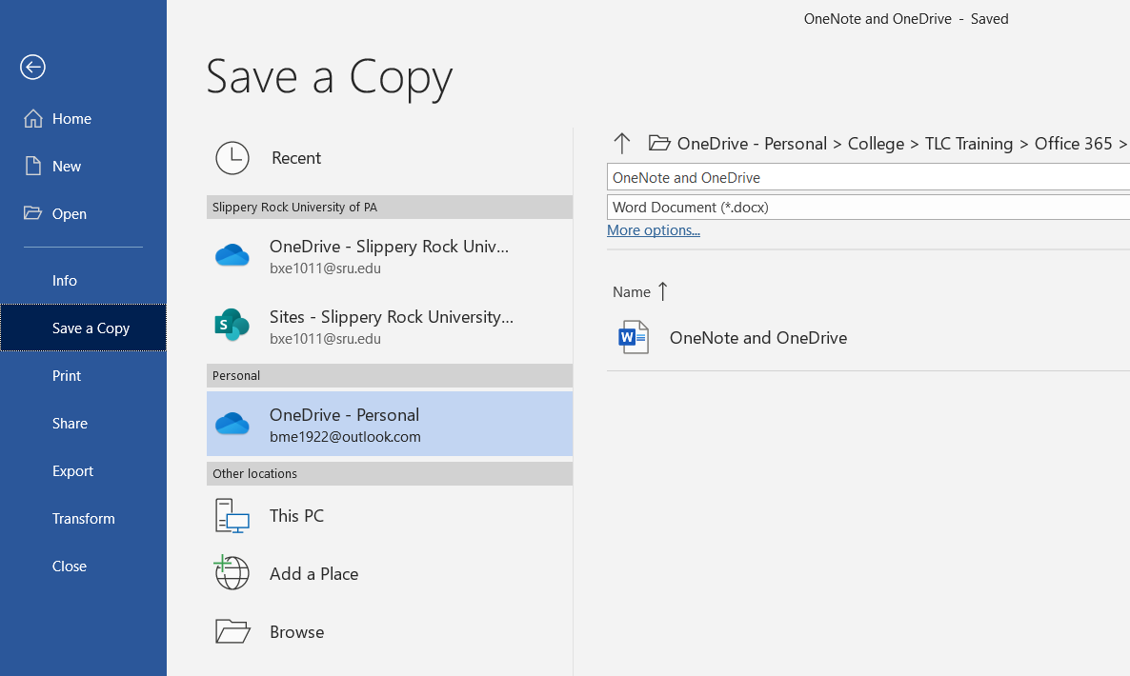

Tip Five: Sharing OneDrive Links
Step One: On the Office 365 homepage click on the OneDrive tab.
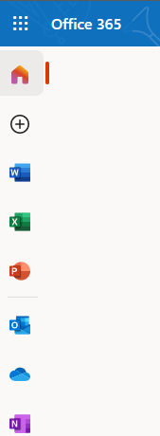

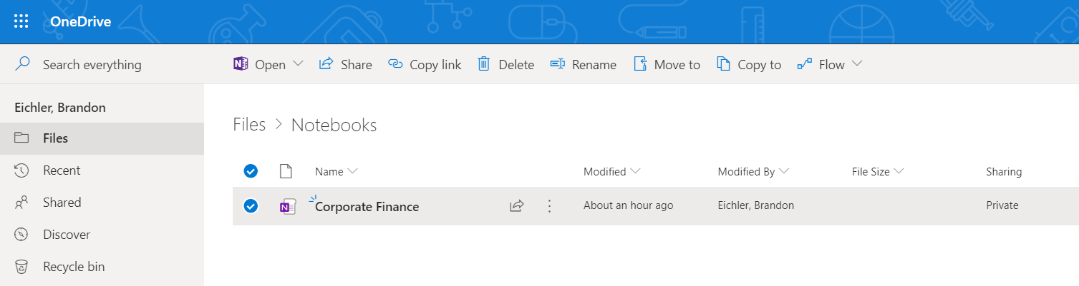
Step Two: Once you are in the OneDrive you are able to choose the file you want to share. Once you have chosen the file, click the checkmark beside the file. At the top of the page there is an option to share. There is also the option to copy the link, download the file, move to a different folder, copy the file, or rename the file. Click on the “Share” icon.

Step Three: Here, you are able to share the file via email. This will send the recipient a link which will give them access to the file. View step four to find out how to edit the link settings.
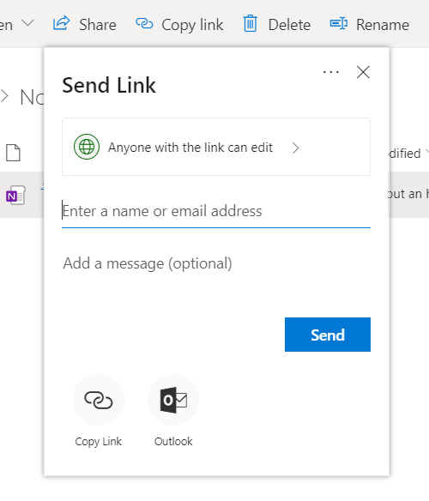

Step Four: To change the permissions of the link, click on the box that says, “Anyone with the link can edit”. This will open a new window that will allow you to specify who the link will for. You can also change if you want the recipient to be able to edit the file. As the creator of the file you can set an expiration date for link as well as a password.
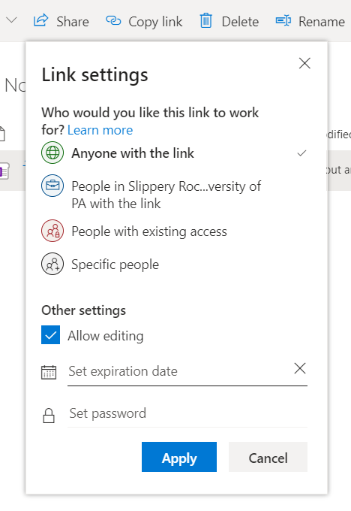

Tip Six: Saving a file from Outlook to OneDrive
Step One: In Outlook when someone sends you a file you have the option to save the attachment to your OneDrive account. When you click on the arrow to the right of the file you have a preview, download, and save to OneDrive option. When you save to your OneDrive account, the saved filed will save to your attachments folder.
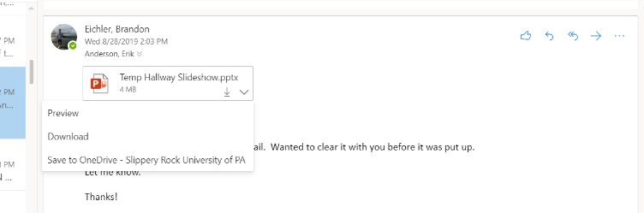

Tip Seven: Seeing Files that were Shared with You
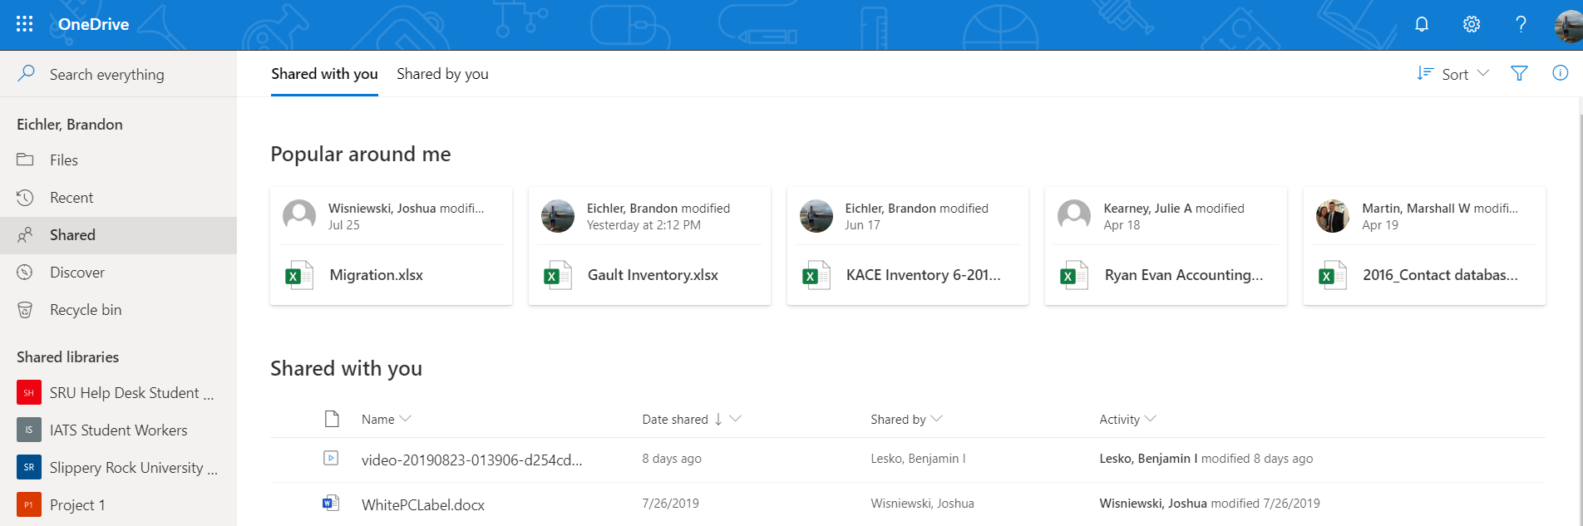
Step One: On the left-hand side of the OneDrive page there is a section titled “Shared”. Within the shared section, you can view files that have been shared with you and files that have been shared by you. You are able to download and view the different files and view them anywhere you have internet access.

