Module One
Outlook and Calendar Tips and Tricks

Tip One: Email Signature
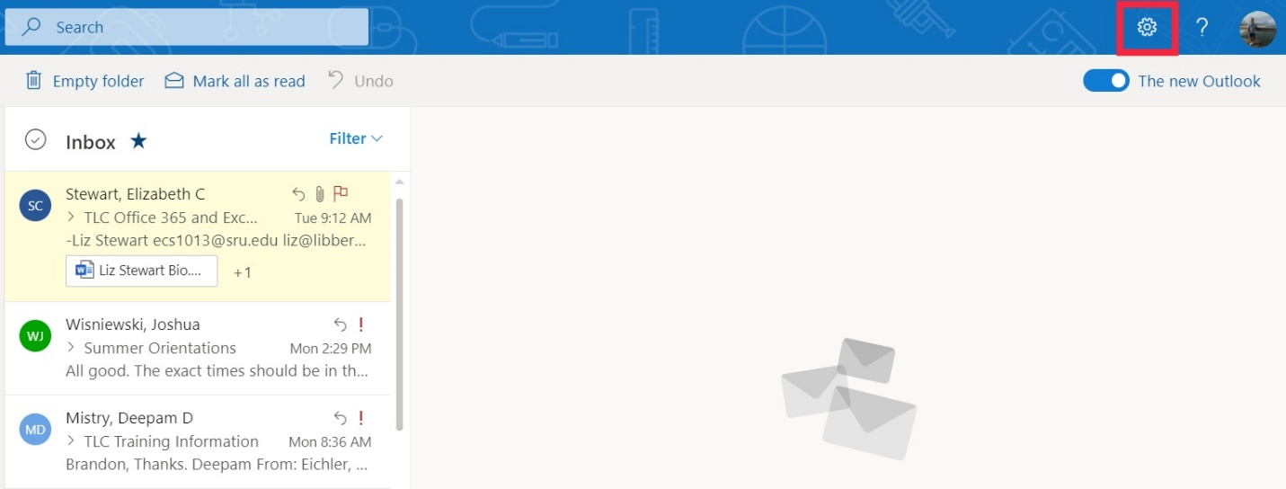
Step 1: Click the settings icon (gearbox) in the top right-hand corner.
Step 2: In the search bar, start to type in “signature”. Within the results, click on “Email signature”.
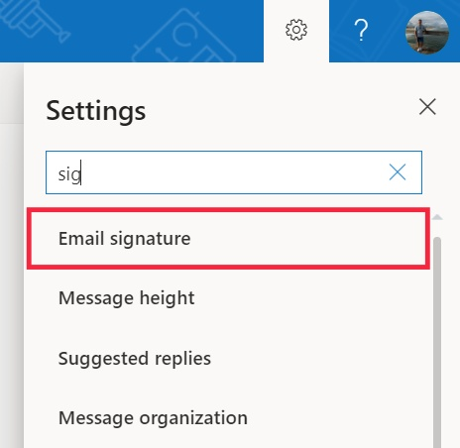

Step 3: Once clicked, you will be able to create your own unique signature that will close each email. Be sure to check both boxes, below, so that your unique signature is automatically included in all newly composed messages, forwarded messages, and any replies. Also, click the “Save” icon that is located towards the top of the window. DO NOT EXIT OUT OF SETTINGS WINDOW SO THAT YOU CAN COMPLETE THE NEXT TIP!
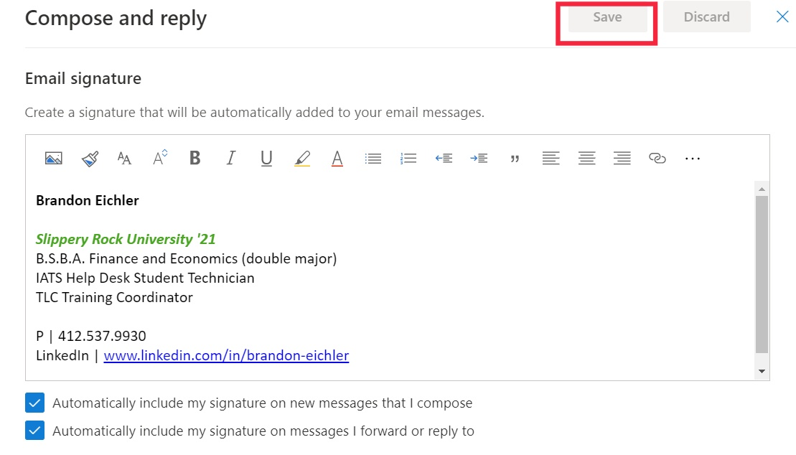

Tip Two: Automatic Reply
Step 1: To start, locate the search bar on the left-hand side of the settings menu.
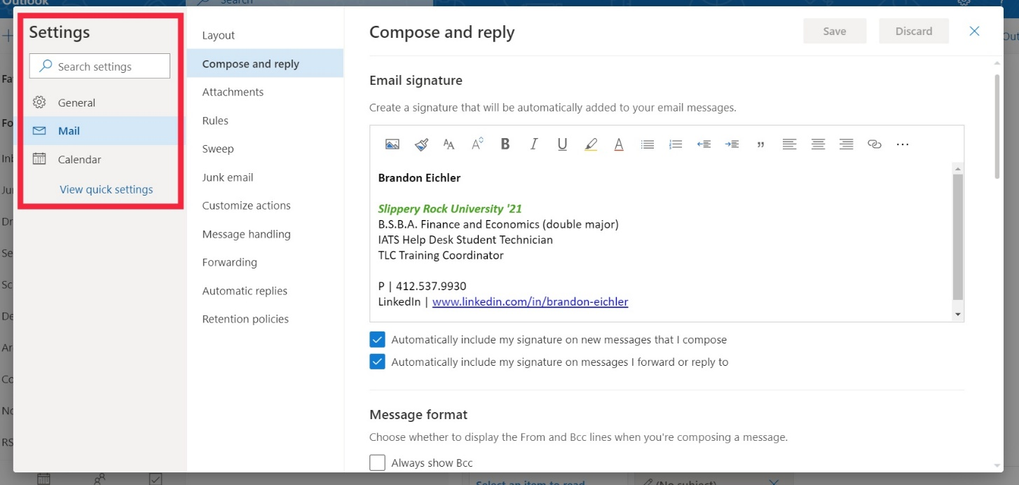

Step 2: In the search bar, type in “automatic” and then “automatic replies” will appear to the right. Click on this.
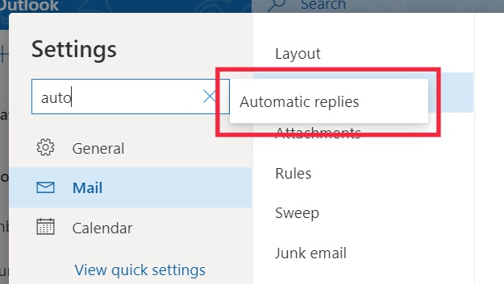

Step 3: In this window you can set up when you want your automatic replies to be sent, how long they will be sent for, and what you would like the message to include. When you are finished, be sure to click the “Saved” icon. You are also able to click the check boxes to have all meetings during this time declined, have the time period blocked so no meetings can be scheduled, and automatically have it let people know you cannot attend any events during the time.
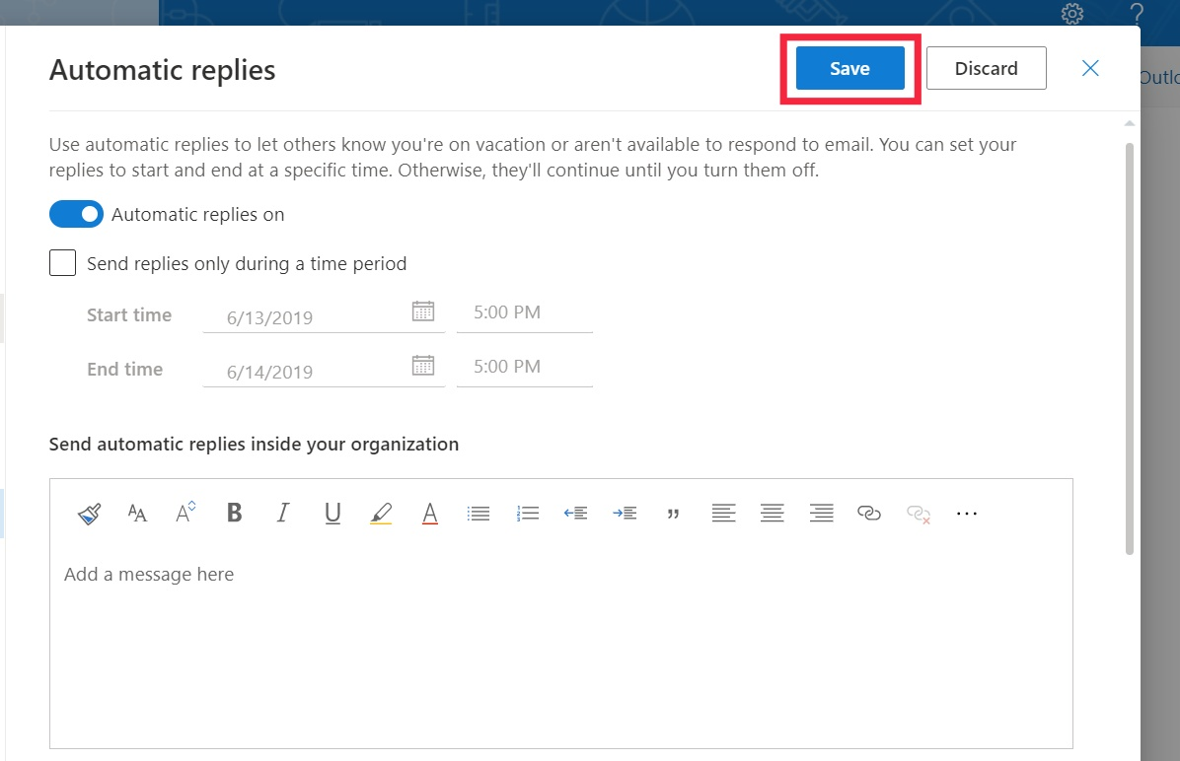

Tip Three: Setting Specific Settings for Emails
Step 1: Create a new e-mail by clicking the “+ New Message” icon.
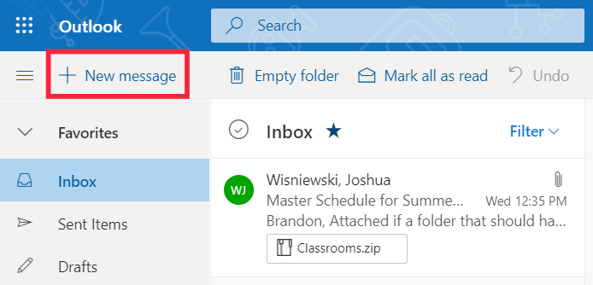

Step 2: Next, Click the three circles to get to more options, then go down the list untill you get to the “Show Message options” and click on that.
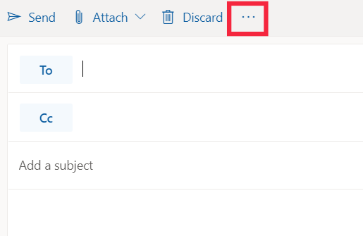
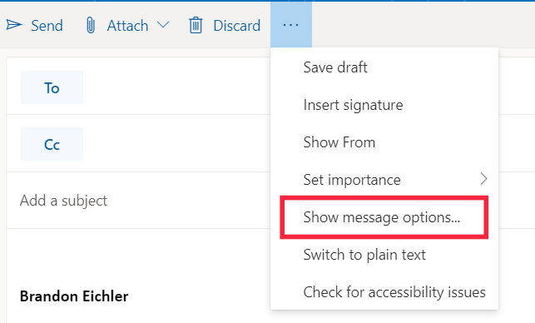

Step 3: Once in this tab, you can set the sensitivity of the email, whether it is normal, personal, private, or confidential. Then you will be able to choose if you want a delivery or read receipt which will let you know when the user receives and reads an email. You are also able to choose to encrypt the email or digitally sign the email, most commonly used with sensitive information.
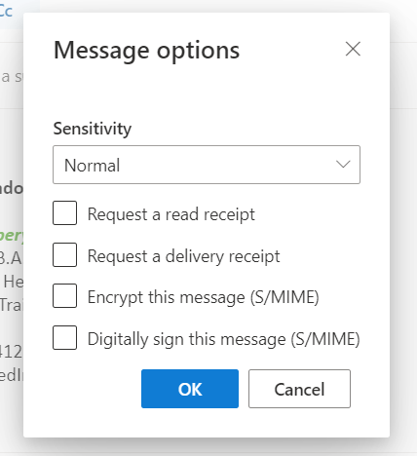

Tip Four: Keyboard Shortcuts
Press | To do this
Alt + S | Will send the message you have typed
Ctrl + S | Saves the current message you are typing as a draft
Ctrl + R | Reply to the message you have open
↑ and ↓ key | Move between messages

Tip Five: Adding a photo on Account
Step 1: In the upper right-hand side of your screen, click the circular account icon. Then click on the large photo icon to the left pf your name.
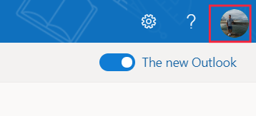

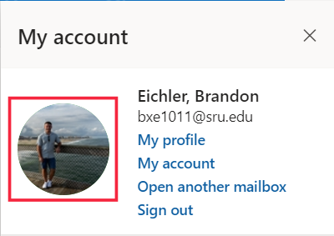

Step 2: Here, you can add or change your account photo by clicking “Upload a new photo”. This will open the file manager of your PC or Mac so that you can select the desired image.
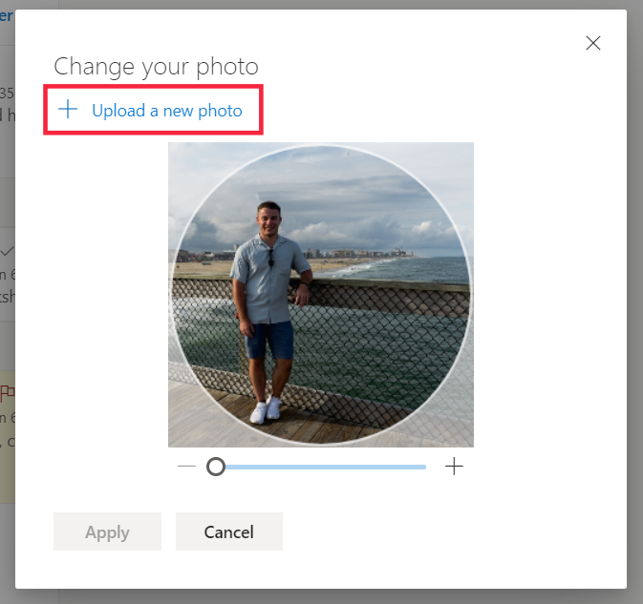

Tip Six: Setting inbox rules for messages
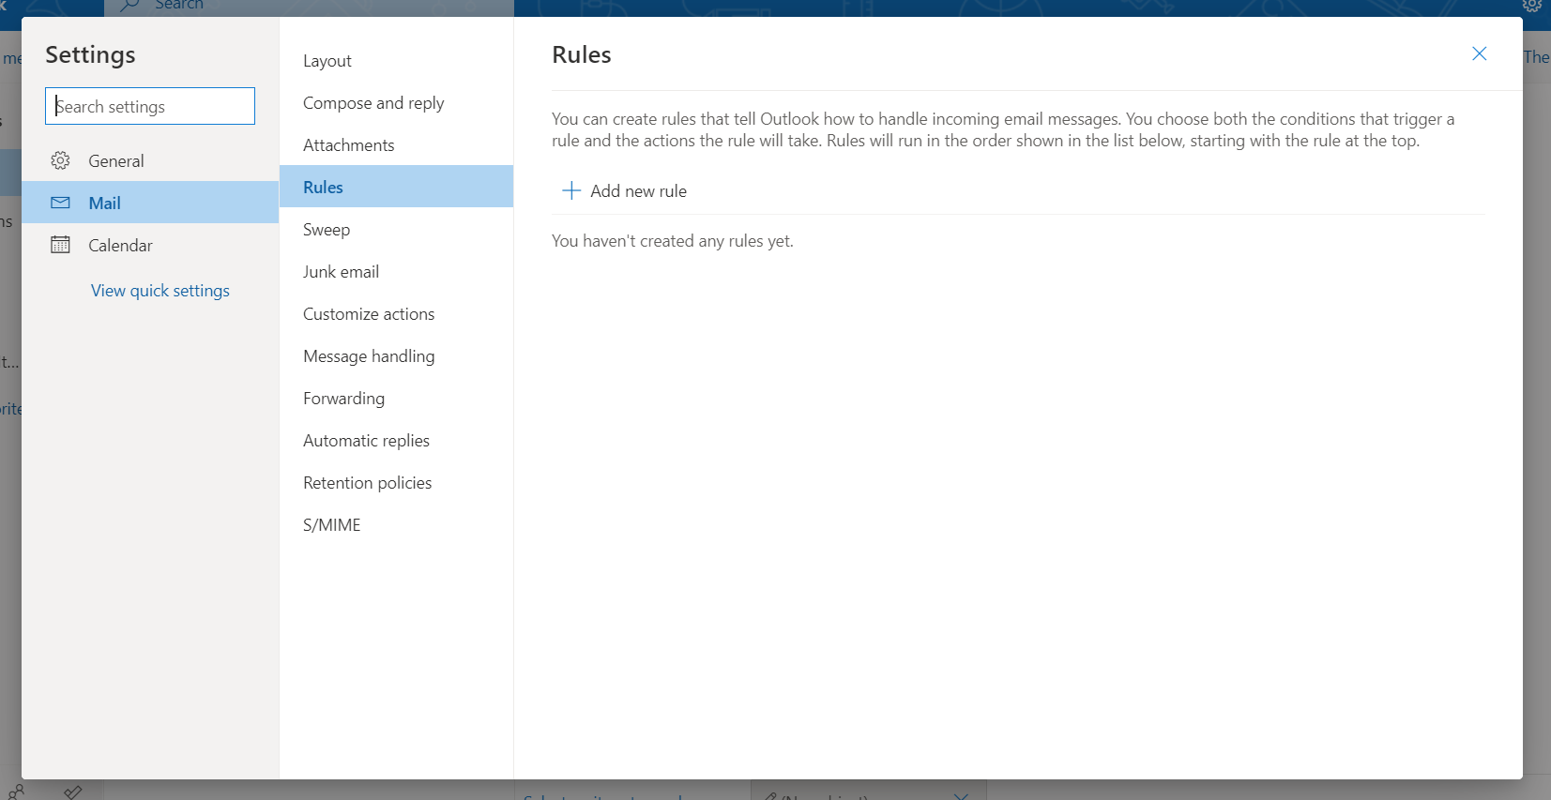
Step 1: To access the inbox rules for your account, click on the gear icon in the upper right-hand corner. Then, click on “View all Outlook settings” at the bottom of the window. Here, you will want to click on “Mail”, then “Rules”, and lastly “Add new rule”.

Step 2: Inbox rules are conditions and actions that you create for incoming messages. We will go through one example so that you can get an idea of what kind of inbox rules you can create. First, you will want to create a unique name for the rule. As you can see in the image below, I named mine “Class”. Next, you will want to create a condition. I set my condition to include any message body that includes the words Notes, Class, and Homework. Lastly, you will want to create an action for the condition you created. My action that I selected will set the messages that fit my condition criteria to high importance. You can also add an exception to the unbox rule. My exception will stop my inbox rule from working after December 13th (This will stop setting messages I receive that fit my condition to High Importance after my winter classes end on the 13th).
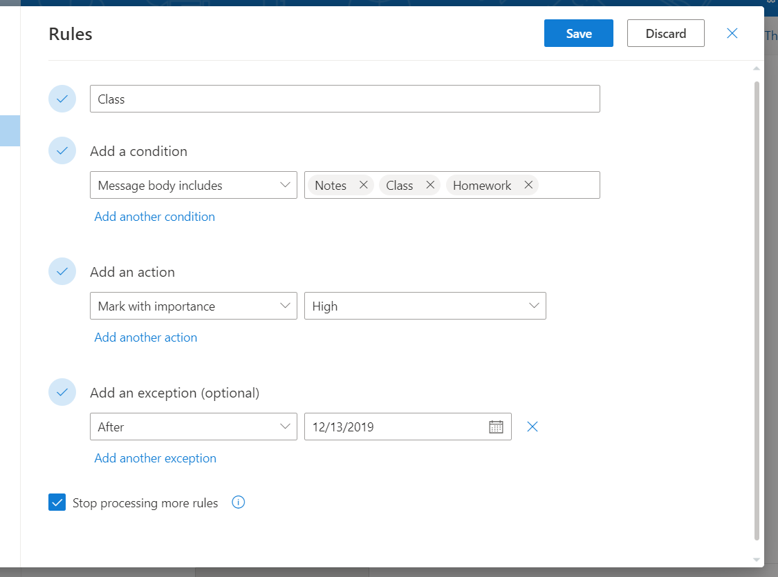
For any message that fits your condition, and would like subsequent rules to be ignored, check “Stop processing more rules”. If you would like a more in-depth explanation with an example, please click on the upside-down exclamation point.

Tip Seven: Narrowing your Outlook Search
Step 1: Outlook uses what's called prefix matching when searching. So, if you type ray into the Search box, Outlook will return messages that contain ray, Ray, Raymond, and rays, but not disarray or tray. Outlook has advanced search feature where you can use operators to narrow your search. There is a short table of some below. There are more that can be looked on Microsoft’s webpage. The link can be found under the “services” page of the Bailey Library.
Type this: | To find this:
hasattachment:yes | Items that have attachments. You can also use hasattachment:true to get the same results.
“home” | Items containing the exact phrase home and not the variations such as homework. To search for an exact string, you must use quotation marks.
from:"Carol Rissmiller"about:"sysaid" | Items sent from Carol Rissmiller where sysaid appears in the subject line, body, or attachment contents. Note the use of double quotes so that the search results match the exact phrase within the quotes.
received:=2/8/2020 | Items that arrived on 2/8/2020. Note the use of the "equals" comparison operator (=).
received:yesterday | Items arrived that have arrived the previous day. You can also use days of the week or months to narrow your search result.

Tip Eight: Outlook’s Advanced Search Function
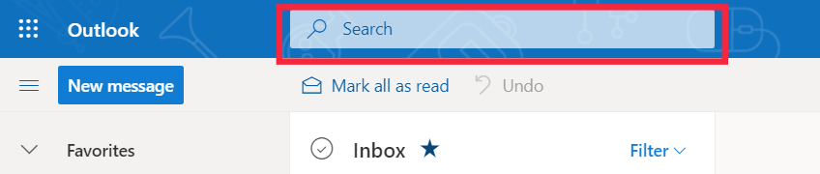
Step 1: Another way to narrow your search results is to use Outlook’s built in advanced search function. To access this, click within the search bar at the top of the screen.

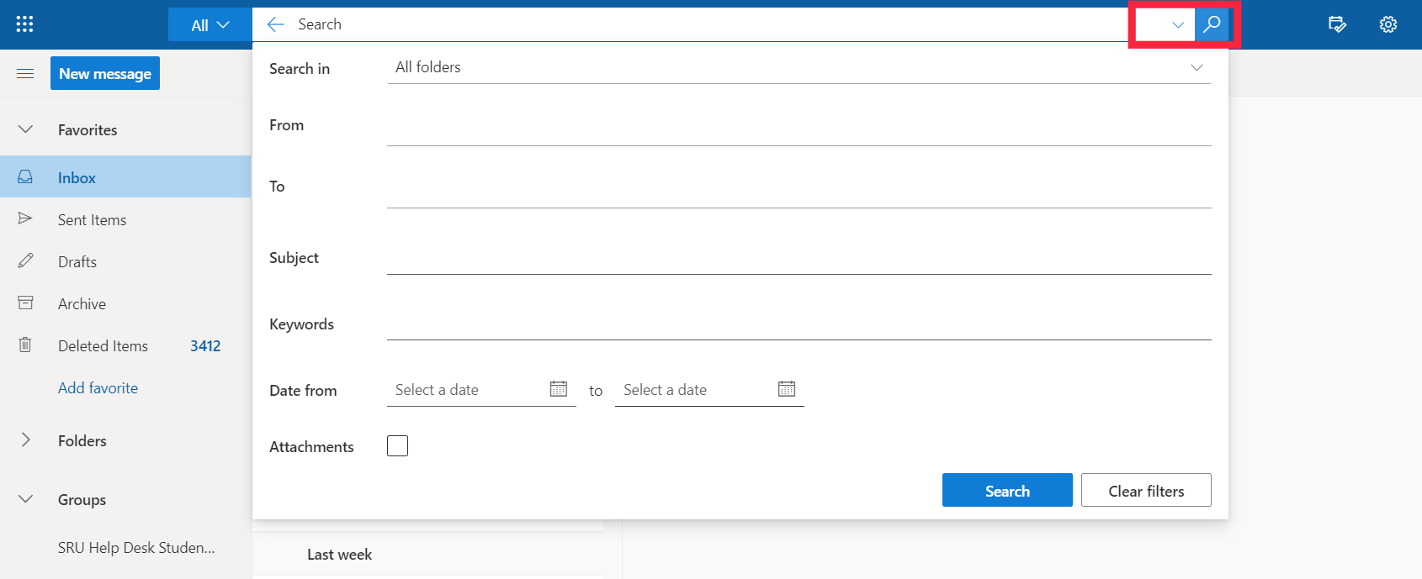
Step 2: Next, click the down arrow next to the magnifying glass. This will pop down a window where adjust search criteria such as specific folders, keywords, and a range of dates.

Tip Nine: Creating a Calendar Event in Outlook
Step 1: On the left-hand side of outlook you will see four small icons in one column. You will want to click on the second one from that top that looks like a calendar.
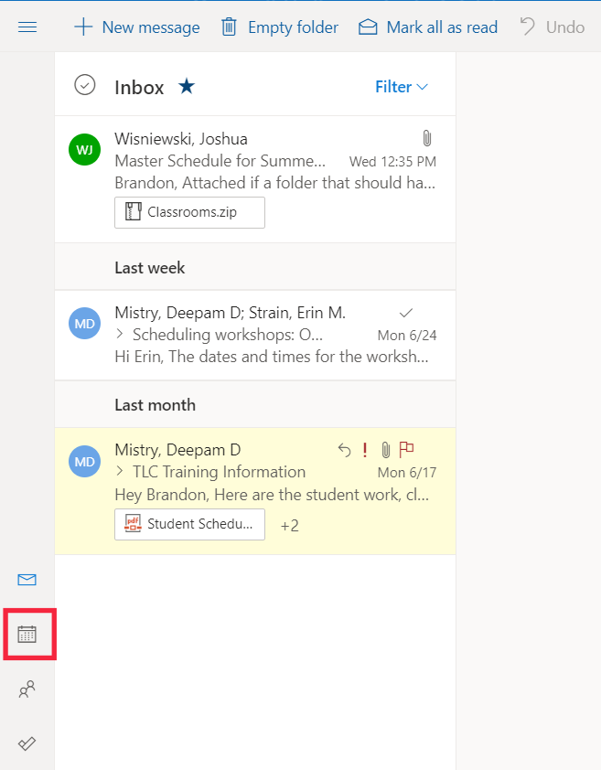

Step 2: Once in calendar, you will want to create a new event by clicking on “New event”. This will open a window where you can create your desired event.
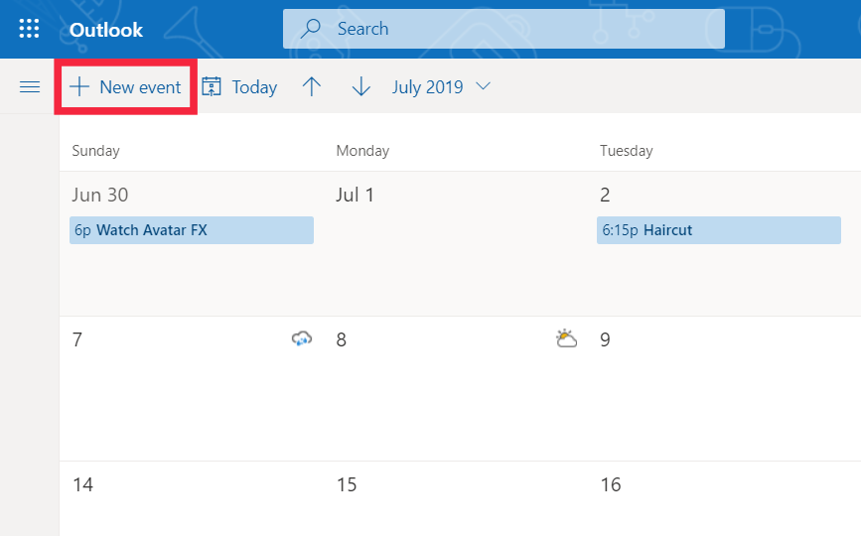

Step 3: In this window, you name the event, add optional or required attendees, pick a date, time, and location for the event, as well as setting up a reminder for the event. The left hand-side of the window will tell you if the attendees are available during the selected time. If you picked a location, it will also tell you the availability of the selected location.

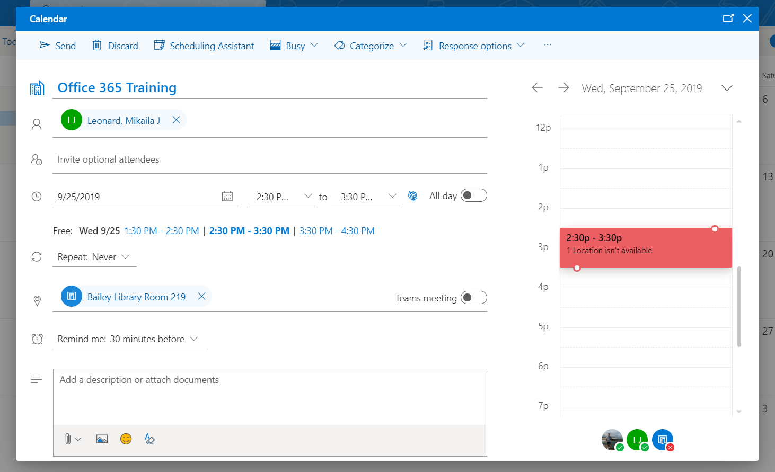

Tip Ten: Importing a Calendar
Step 1: To access the import calendar window, you may need to click on the menu icon (hamburger icon) next to the “New event” icon. Once the menu is open, you will want to click on “Import Calendar”.
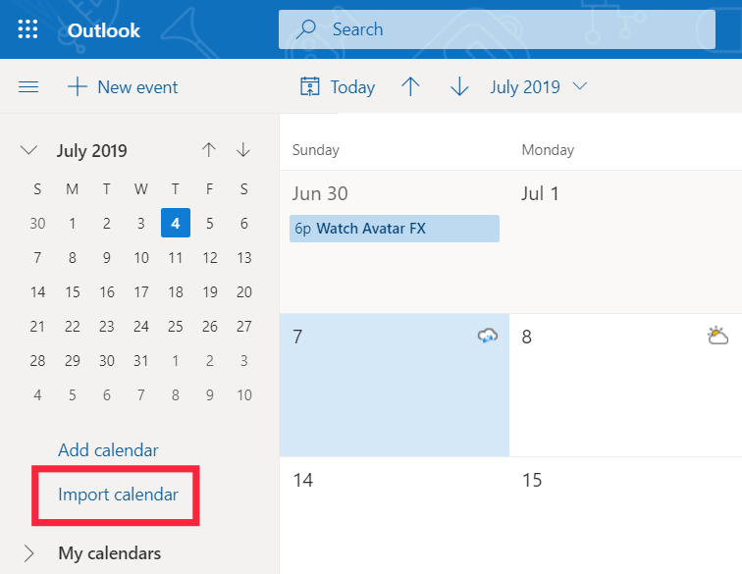

Step 2: In this window you can import the schedule for sports teams, holidays for a specific country, or an external calendar from a file, web, or directory.
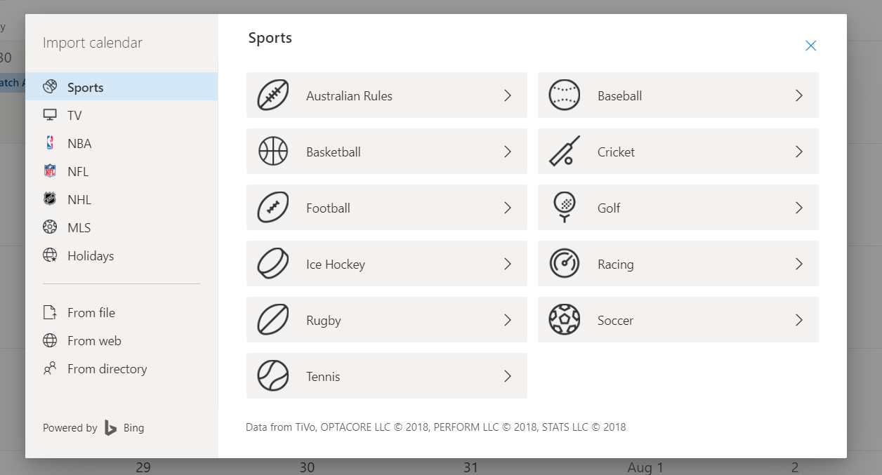
Tip Eleven: Creating a New Calendar
Step 1: Within the calendar menu, click on “Add calendar”. You can then name your calendar.
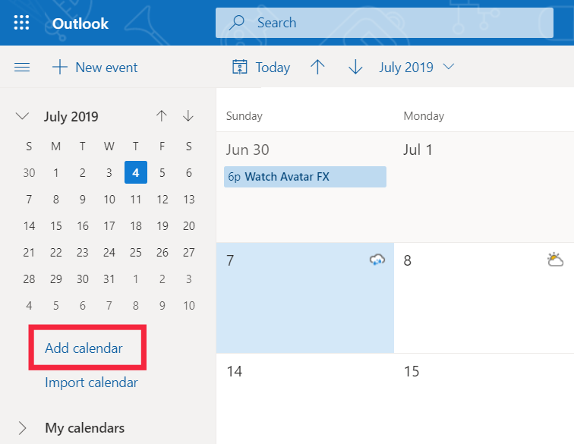

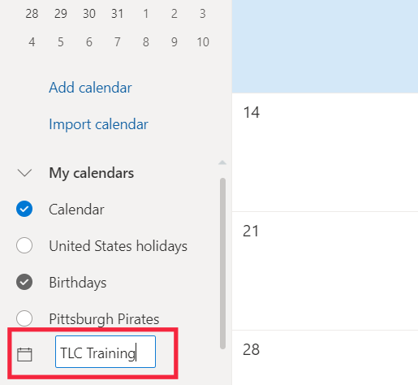

Step 2: To create an event for your new calendar, click the “New event” icon. Then, you will need to change the calendar by clicking the down arrow in the top left of the window.
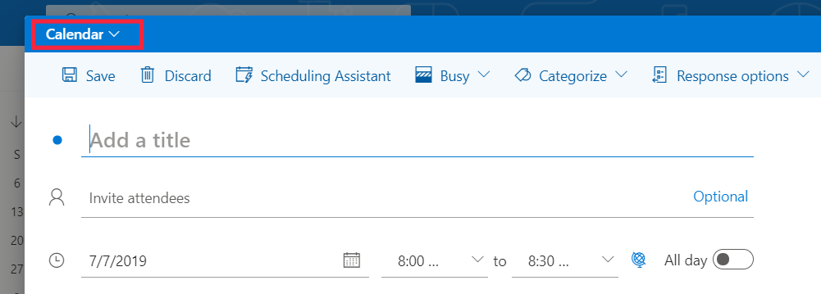

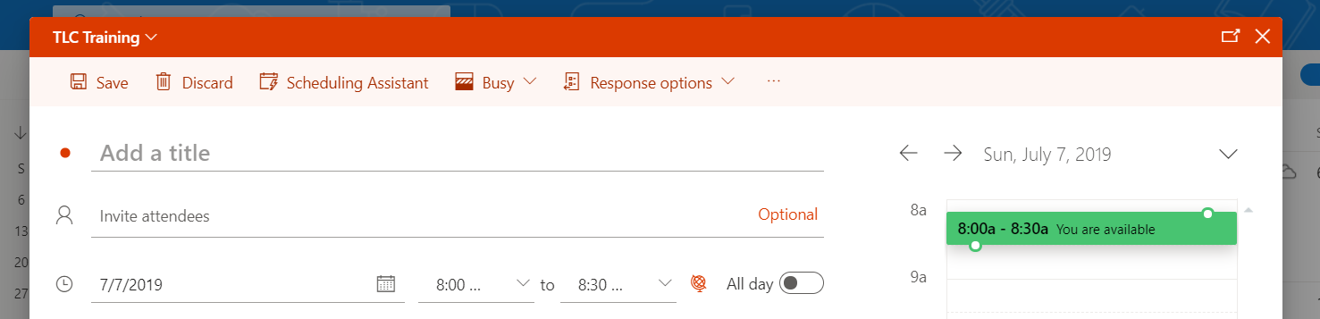
Step 3: You can then select your desired calendar to add your new event.
Tip Twelve: Outlook Add-in FindTime
Step 1: If you do not already have the FindTime add-in downloaded to your Office 365 account, you will need to do that by accessing the following link:
https://findtime.microsoft.com/
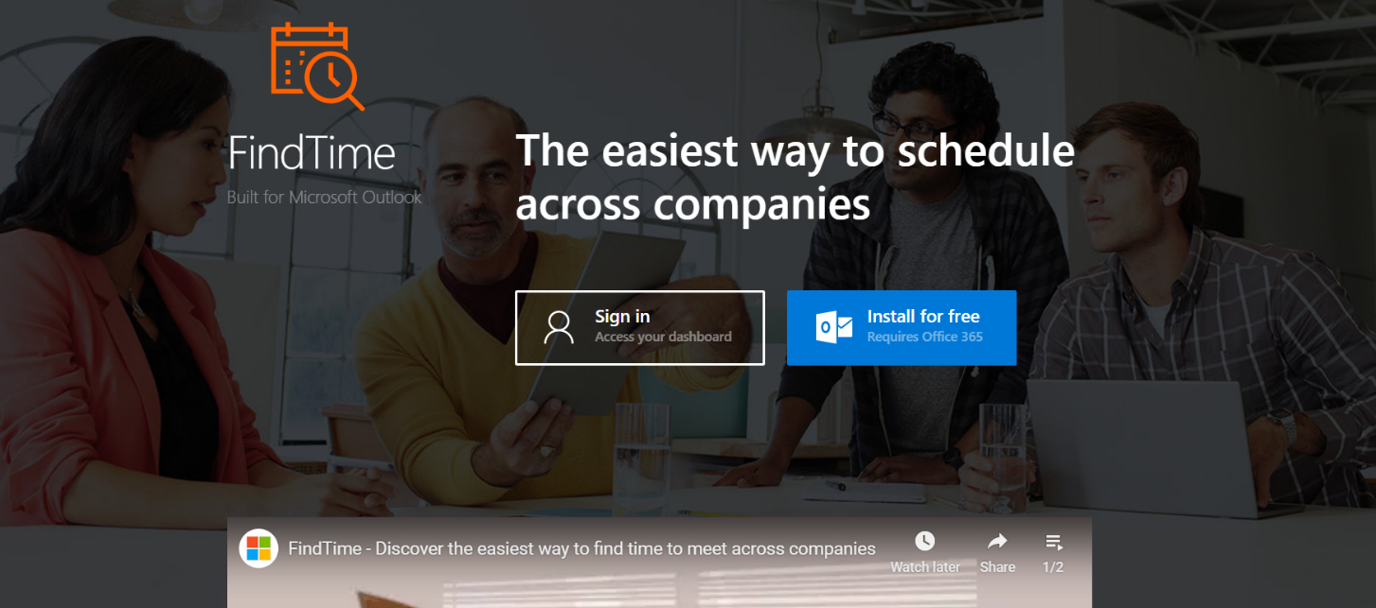
Step 2: Next, you will want to click on the blue “Install for free” icon. It should then redirect you to another page where it will prompt you to sign into your Outlook account. Once finished, it should take you back to the FindTime page where the blue icon should now be a green icon and say “Installed”.

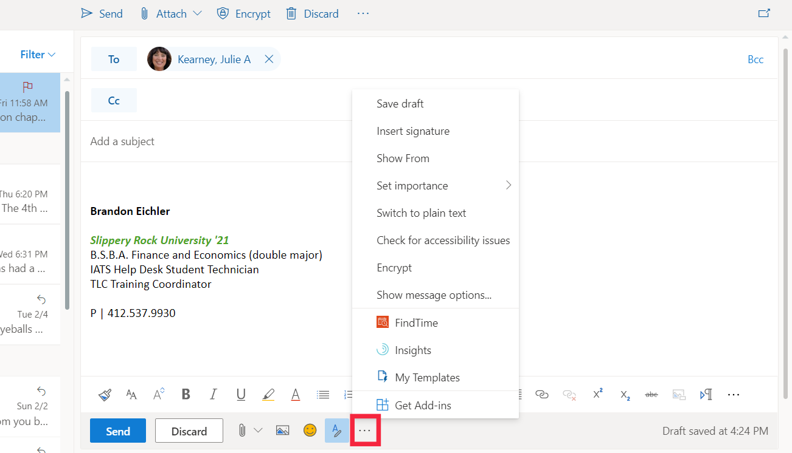
Step 3: When creating a new message, click on the horizontal three dots, check picture below, to open up options window. You should then see the red FindTime icon towards the bottom. After clicking on that, a vertical window on the left-hand side of your screen should display where you can begin to create your FindTime.
Step 4: In this window, you can set the duration of the meeting, whether or not the meeting is during working hours, and the date and time of the proposed meeting. You can select multiple dates and times for the proposed meeting to give the maximum amount of options to the attendees. (Picture on next page)
Step 5: After completing selections for step 4 and clicking “next”, you are able to select a location, choose the option to have the meeting online, and select additional meeting settings. These additional settings include the following:
Setting | What it does
Notifications | Sends you an email when attendees vote. The email includes the current poll status and an option to schedule immediately.
Auto schedule | Automatically schedules a calendar event if all required attendees vote favorably for a meeting option. If multiple options are available, the earliest will be scheduled.
Holds | Adds an appointment to your calendar for each meeting option you suggest. All hold appointments are removed upon scheduling a meeting option (either by auto schedule or manually on the voting site) or canceling the poll.
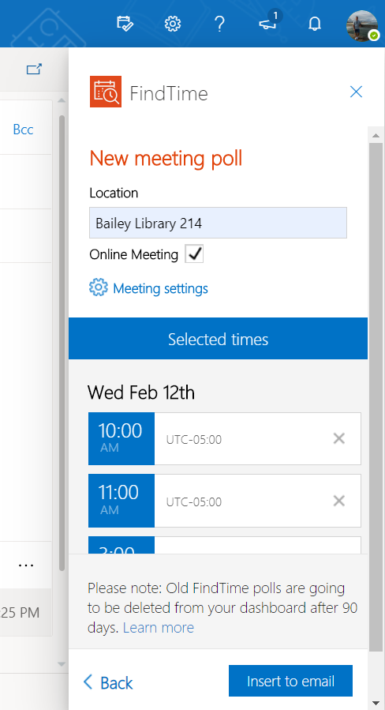
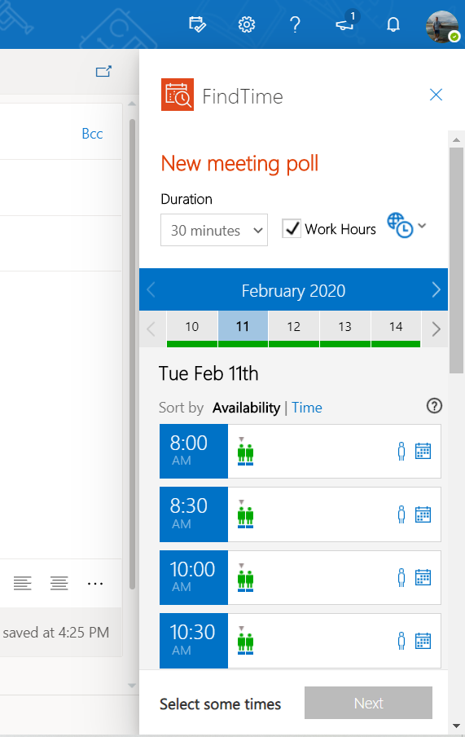
Step 4 Picture Step 5 Picture

Step 5 continued…
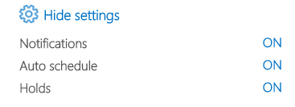

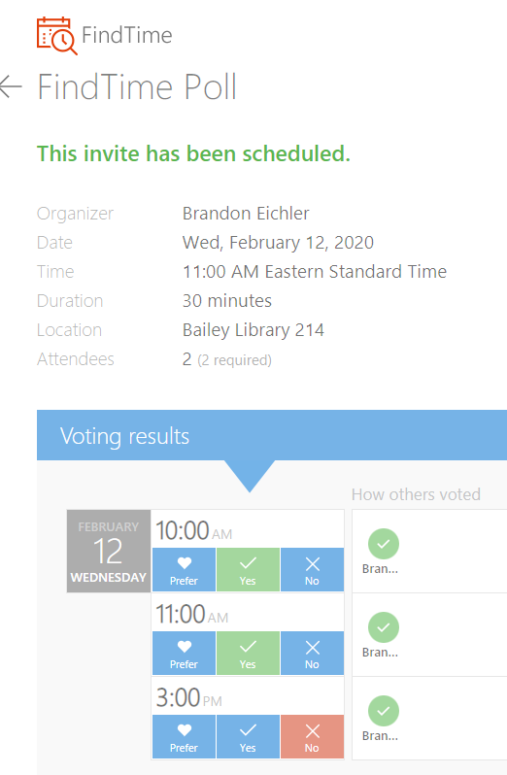
Step 6: Once step 5 is completed, you can select “Insert into email” and it will add it into the email you created. All recipients that are within “To” will be categorized as required attendees. Any recipient within “Cc” will be categorized as optional attendees. I have inserted two pictures below so that you know what the email will look like for the recipients.

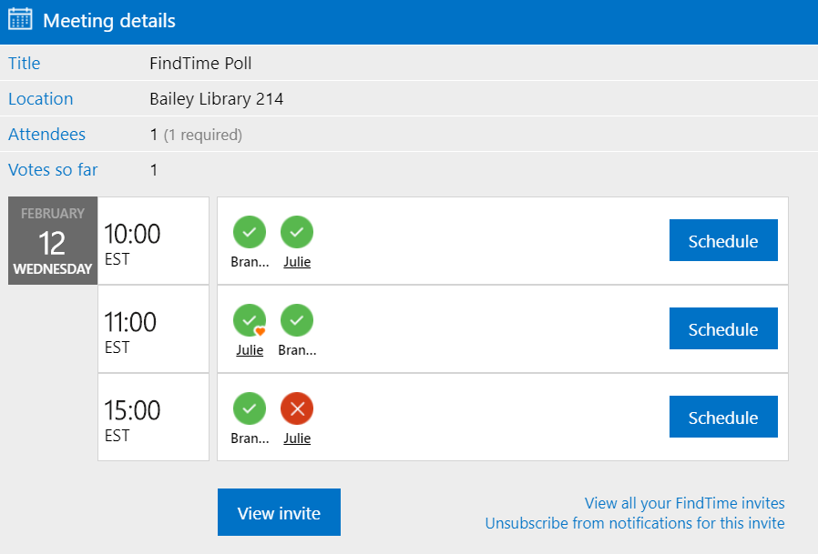

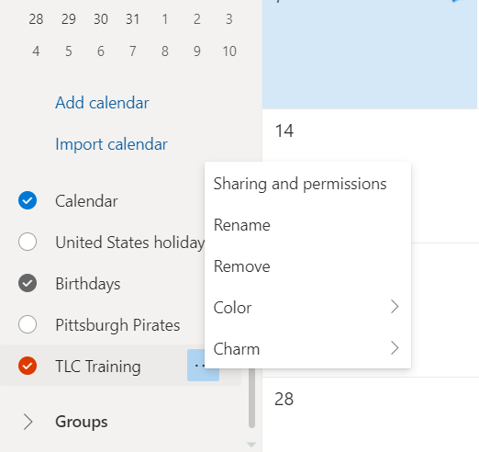
Tip 13: Customizing the settings of a calendar
If you click on the three dots to the right of your calendar name you will open a settings window. Here, you can change the color of the calendar so that it does not blend in with others. You can also add a charm to your new calendar that just adds more customizability.

