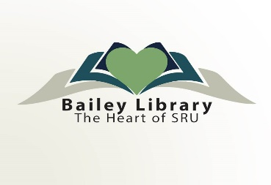
August 2, 2021

Dear EZBorrow service users:

We’re excited to let you know that EZBorrow, the service that underpins Bailey Library’s automated interlibrary loan program for borrowing books and other physical items from libraries throughout our region, is migrating to a new technology platform in mid-August (anticipated date of August 10th)!

Why the change?

This new platform allows libraries to improve service to our patrons by using the latest library technology. The open source code gives libraries more customization options and allows them to more quickly adapt to new technologies and patron needs while keeping operation costs down. The new platform is also owned and governed by a community of libraries and developers, promoting collaboration across libraries and institutions and creating more opportunities for future functionality and patron benefits than ever before.

All of this gives you world-class access to library collections that will only improve going forward!

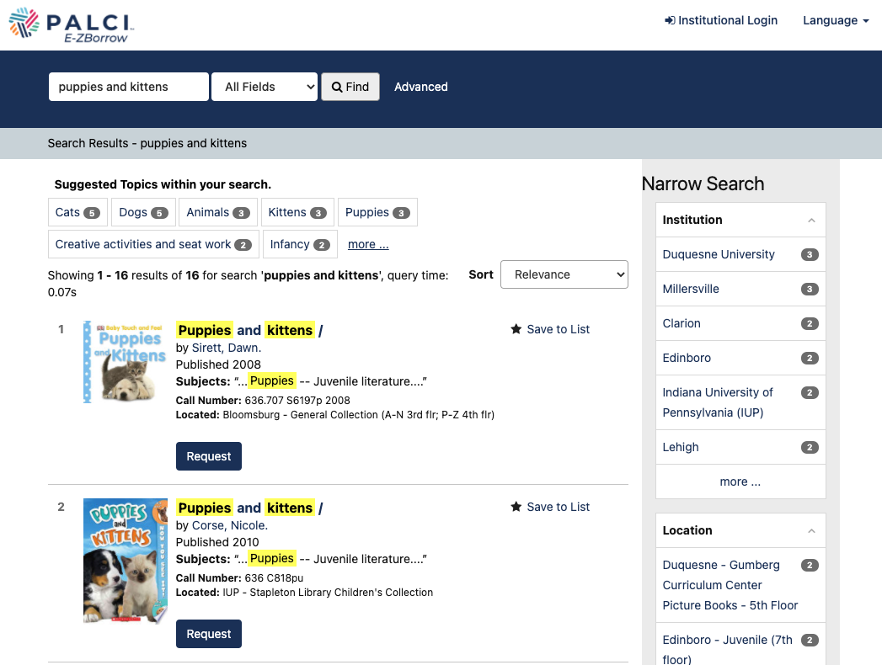
What will be different?

- A new and improved search interface, allowing users to easily browse, find, and request materials held at our 50+ partnering institutions (pictured right)
- Expected new login page that makes use of the same single sign on username/password that you’re used to using elsewhere at Slippery Rock University (this will be coming as soon as development is complete).
- More tools to help library staff fill your requests faster and more accurately
- A new EZBorrow logo

What will be the same?

Although the underlying technology is changing, the key benefits of the EZBorrow service remain the same. You can still check out books from any one of our 60+ university and research library partners around our region with the same speed, efficiency and convenience that EZBorrow has always provided!
Planned Future Enhancements

Today, this new platform supports interlibrary borrowing of books and other physical items in the way you’ve come to expect from E-ZBorrow. In the future, this platform will also allow patrons to borrow electronic materials. Please stay tuned as we continue to improve our interlibrary loan program using this new technology!

What do you need to do?

- Keep requesting materials as usual! Although the platform is changing, the service is the same.
- If you wish to keep your request history, please talk with library staff before August 31 for help downloading this information. This information cannot be moved into the new system, and after August 31st, it will no longer be available.

Questions? Contact us!

Although we aim to make this transition as smoothly as possible, we expect there will be questions! Please don’t hesitate to contact our library staff using the information below:
- Ellen Pontius, Interlibrary Loan Technician, Bailey Library, ellen.pontius@sru.edu 724.738. 4389
- Julie Kearney, Library Systems IT Generalist, julie.kearney@sru.edu 724.738.2814

