Module Three
SharePoint Tips and Tricks

Tip One: Getting Started with SharePoint
Step One: On the Office 365 home page click on the SharePoint icon.
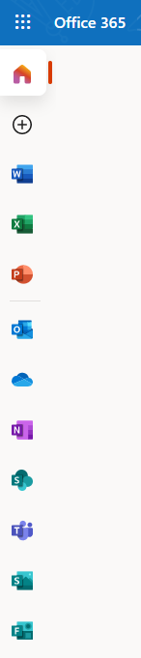

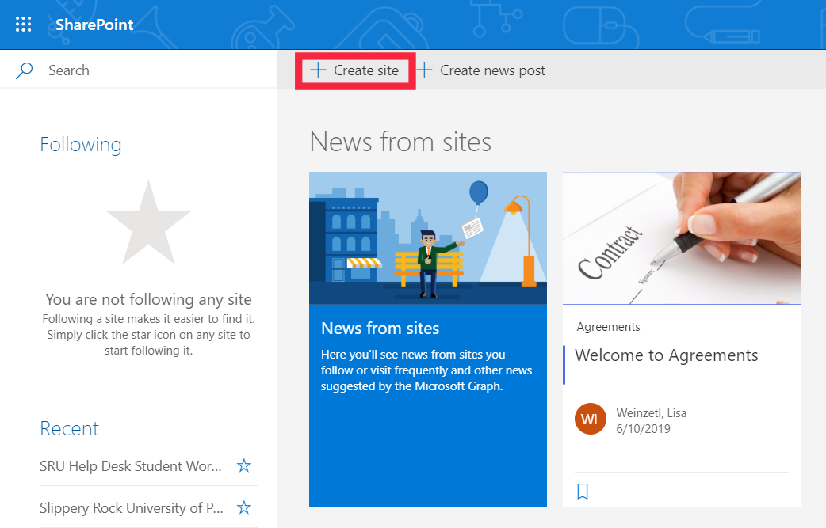
Step Two: Once you get into SharePoint, you can view public sites, news that is published from sites you frequently visit, and other news curated from Microsoft. To create a new site, click on the “Create site” icon.
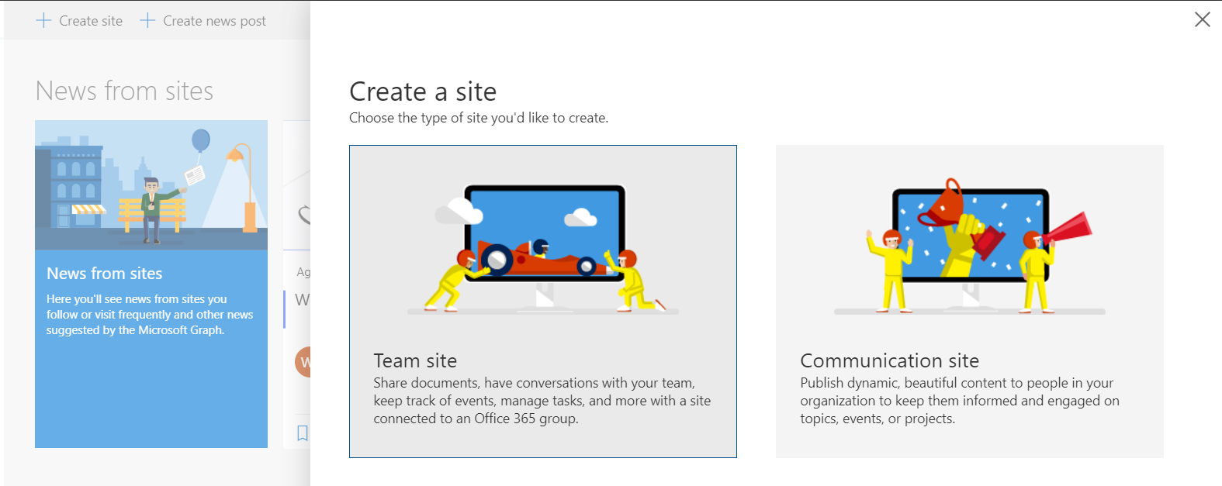
Step Three: On the next window, you can choose how you want to curate your site. Whether it be a team site, for a class for students to collaborate on group projects, or a communication site for you to convey information to them.
Step Four: After you select the type of site, you have the ability to customize it with things such as a site name, description, a site email, and privacy settings.
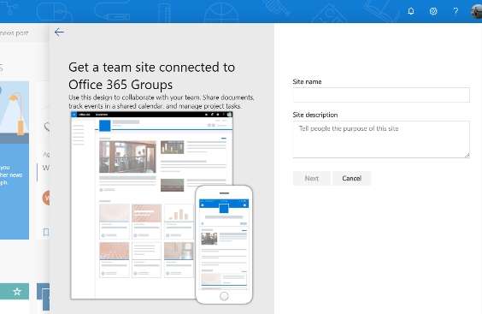

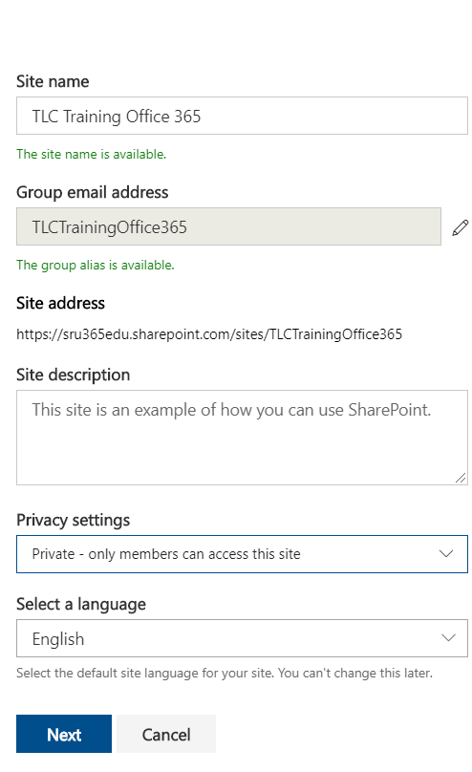

Step Five: Next, you can add additional owners and members. Owners will have the ability to change the sites content. Members only have the ability to view the site.
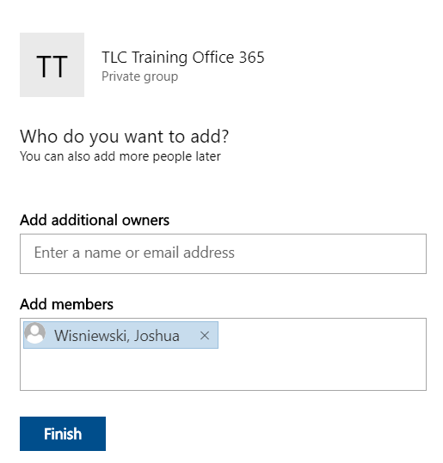

Tip Two: Managing a SharePoint site
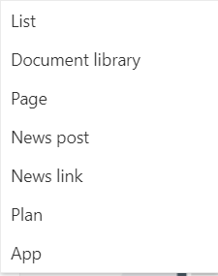
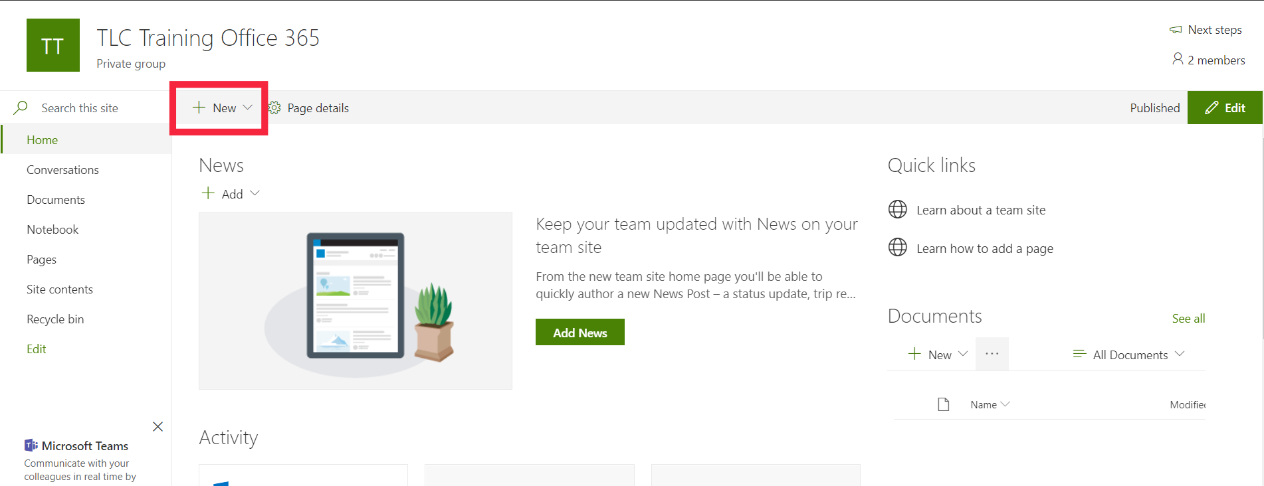
Step One: Once you have successfully created the site, there are many different options for the things that can be done. You can add documents, notebooks, news, as well as uploading documents from Microsoft office onto the site. See the table below for creating new content.
Adding Content
Lists | Create SharePoint lists to keep track of information, including titles, descriptions, people and dates.
document Library | Create a document library in SharePoint to securely store files where you and your co-workers can find them easily, work on them together, and access them from any device at any time. SharePoint team sites include a document library by default, however, you can add additional document and other libraries to a site as needed
page | Using pages is a great way to share ideas using images, Excel, Word and PowerPoint documents, video, and more. This part of SharePoint is where you it starts to look like a web page.
news post | A news post is exactly what it’s called. Think of a news post in a paper article. After a news psot is published it will post on the home page of the SharePoint available for members to read it.
news link | A news link is a link that is posted to the SharePoint site. If you create a new news link, you are able to paste the URL of any internet webpage on your SharePoint site.
plan | When you create a plan, you have the ability to delagte tasks. For rexample, you can create a task for a specieifc group to comeplete a project. You can the student in by email and set a dead line for the task to be completed by.
application | By adding an application you have greater control of adding content. Exmaples include a calendar, survey, or contacts.

