Module Four
Sway and Forms Tips and Tricks

Tip One: Getting Started in Sway
Step One: Click on the Sway icon on the home page of Office 365.
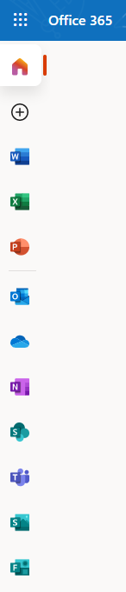

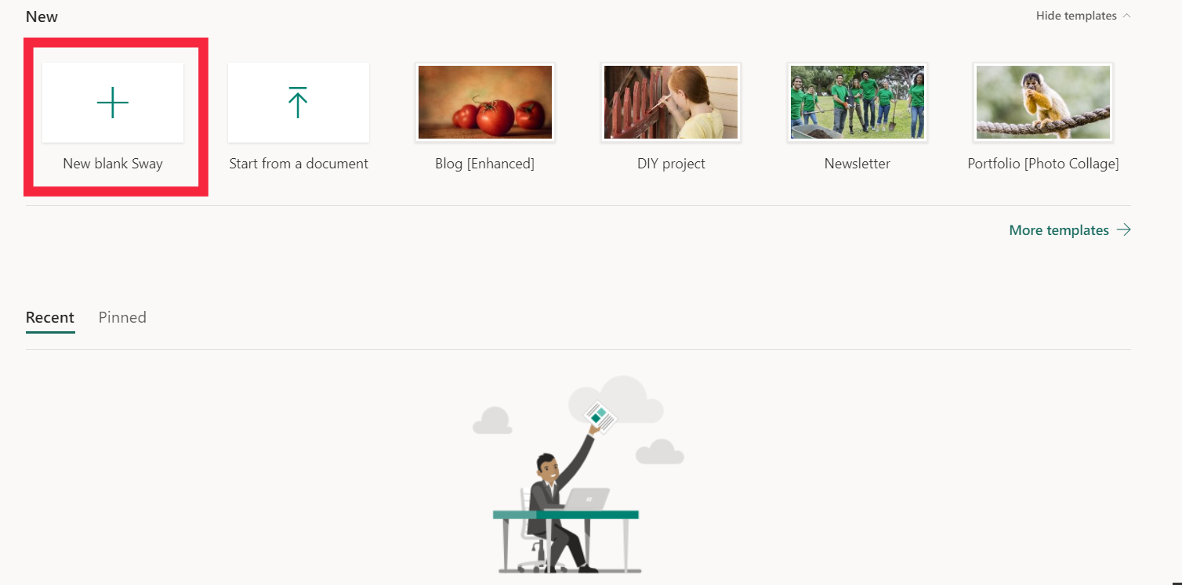
Step Two: At the home page of Sway you can select how you want to start your presentation. Your options are, start a new blank Sway, start from a document you have already created, or choose from select templates.

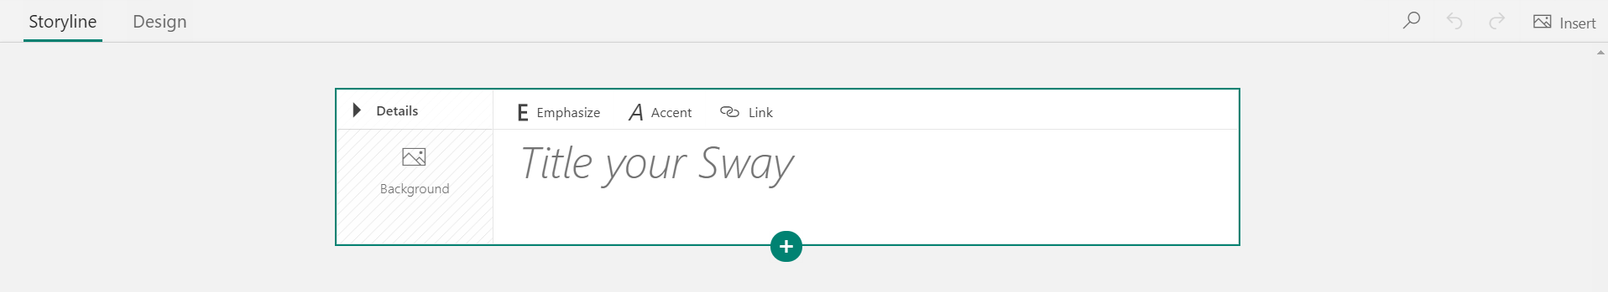
New Blank Sway: When you create a new blank sway, you are able to start from a clean slate to curate the Sway in your own way.

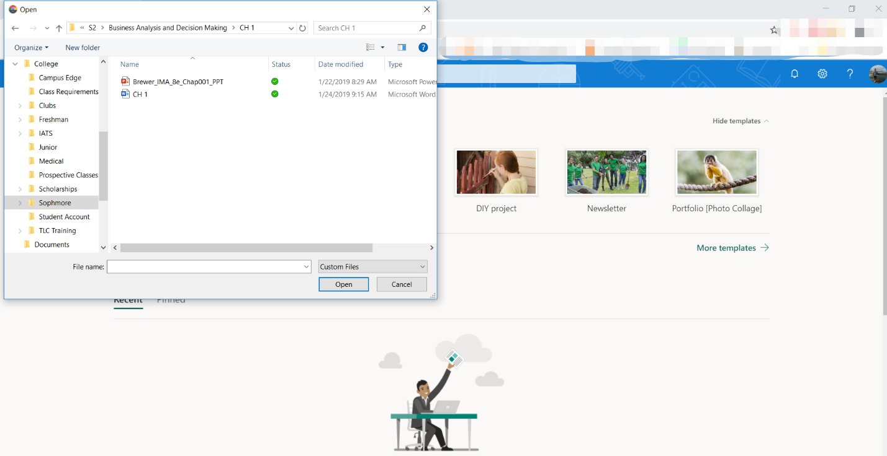
Start from a document: When you click on start from a document you have to choose the document you want to base the presentation off of, so you are able to move forward. This will auto populate the content of the document you selected (text and images) into the Sway.

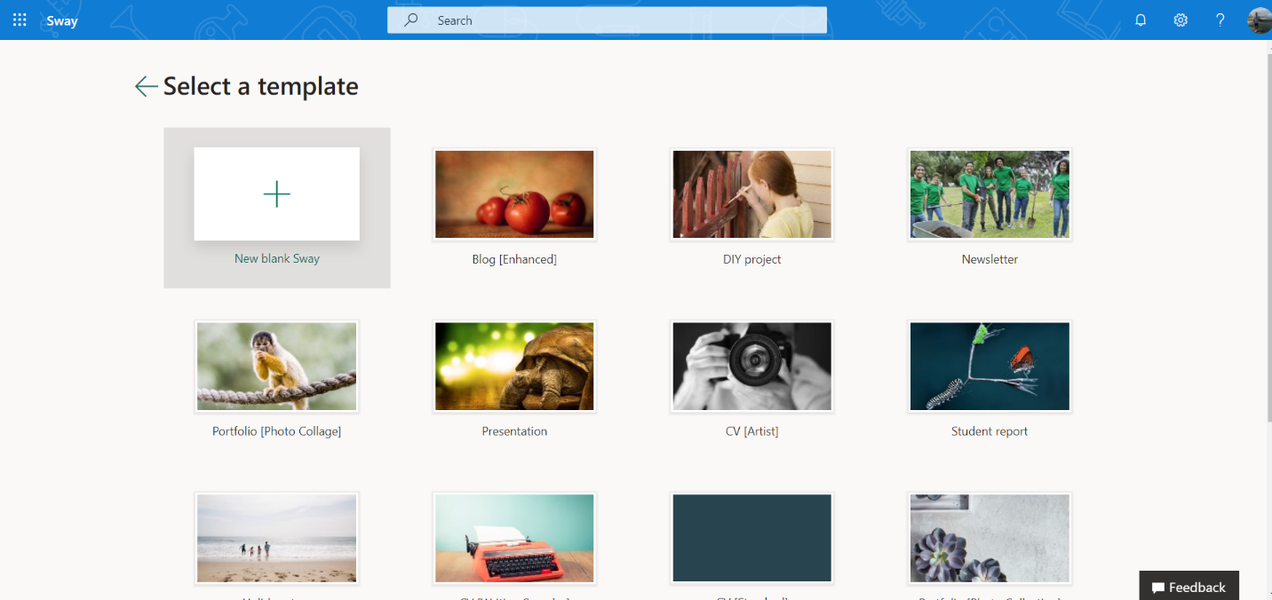
Start from a template: At the home page of Sway, select “More templates” to view all available tempalates. There are a handful to pick from that should get the creative juices flowing.

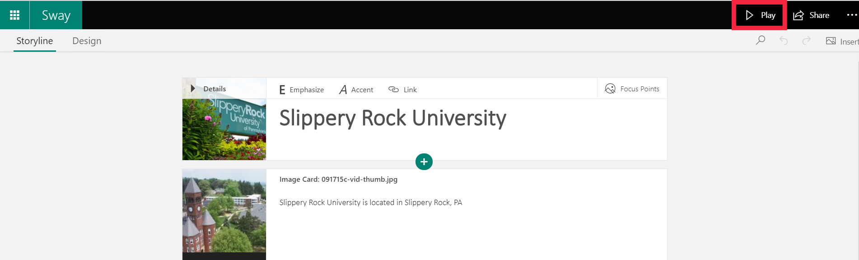
Step Three: When you want to view a preview of your Sway, click the “Play” icon in the top right-hand corner. This will show present your Sway or show you how it will look for others.

Quick Tips
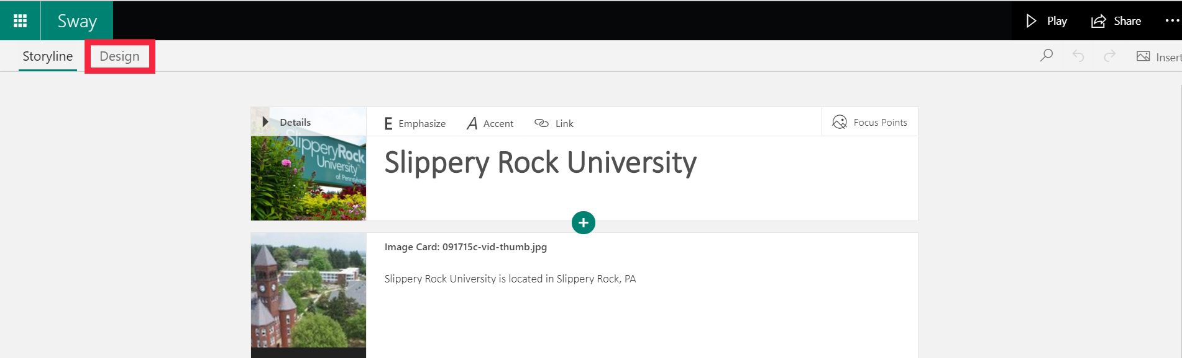
Quick Tip One: Changing the design of your Sway. Click on the “Design” icon.

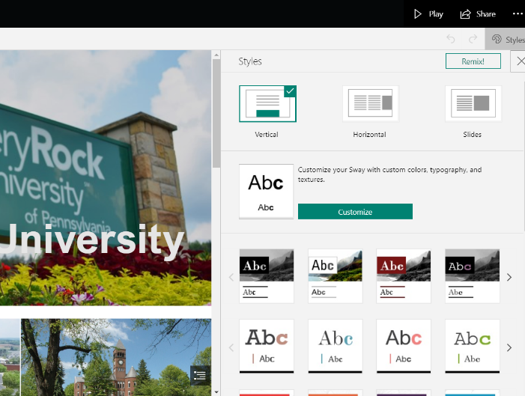
After clicking on the “Design” icon, you can click on the “Styles” icon in the top right-hand corner to customize your design.

Quick tip Two: To view all your cards in the timeline, click the icon in the far bottom right hand corner of your screen. This will allow you to navigate to any card in your Sway.
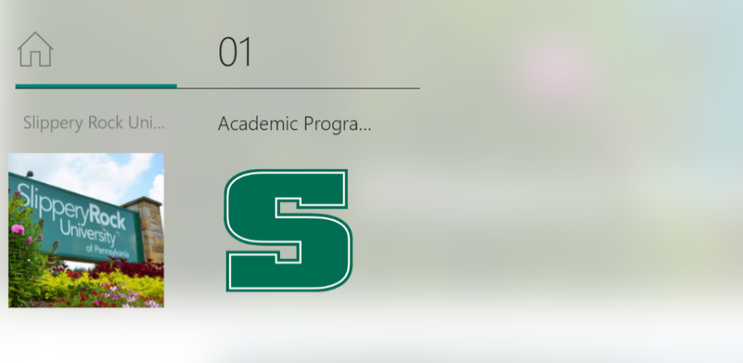

Tip Two: Sharing the Sway
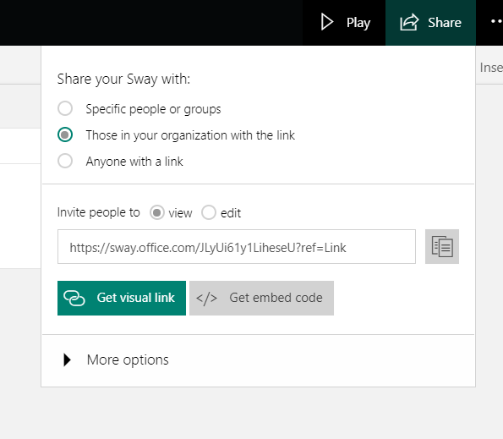
Step One: Once you have finished creating the perfect sway, you will want to share it with others. In order to do this, click on share in the top right-hand corner. Here, you can share your Sway with specific people, those in your organization with the link (such as anyone who goes to SRU), or anyone with the link.

Tip Three: Creating a Form
Step One: Click on the Forms icon on the front page of office 365.

Step Two: On this page you are able to chose either a new quiz or a new form, this choice is based on what you will be using this application for. If you are using it to soley make a form to ask for other’s opinions you should click on new form and if you want to have people answer questions and the questions to have speicifc answers create a new quiz.
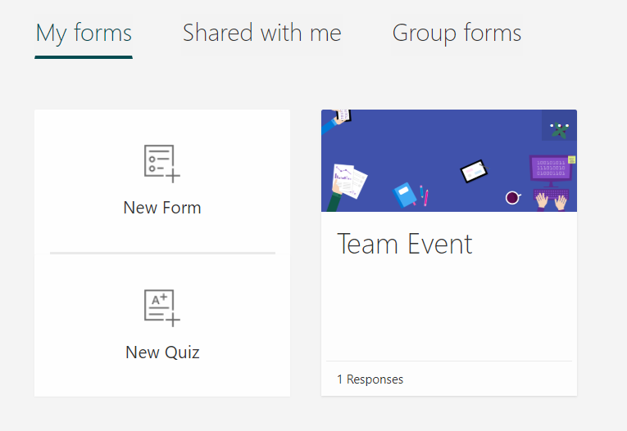
Step Three: To create either one you need to add questions for the users to answer. Once you have all the questions and are ready to share these just click on the share button in the top right corner and you will receive a link. The first link you can create is for anyone that you want only to be to complete the form. The second link is to give access to your Form as a templete for others to use. The last link you can create is for anyone to view and edit the Form.
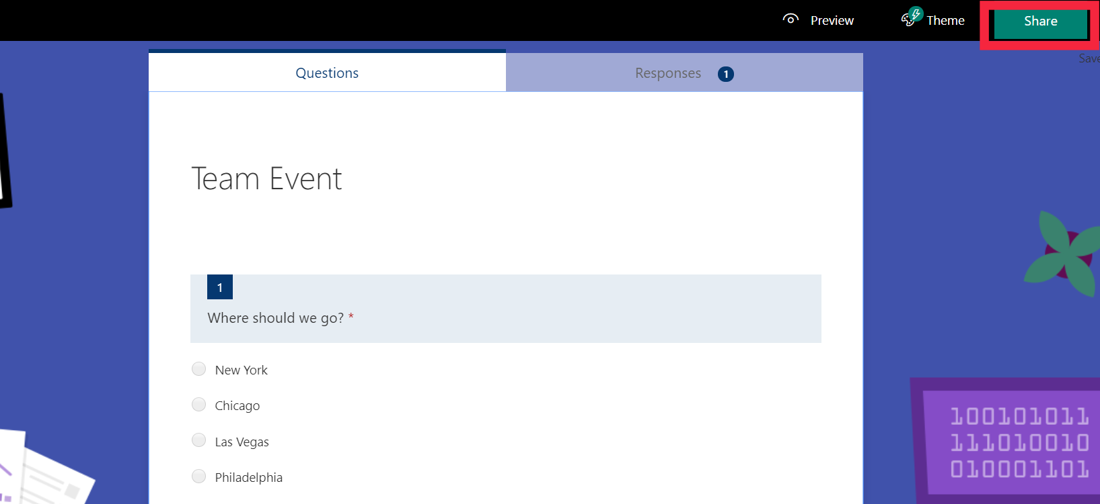
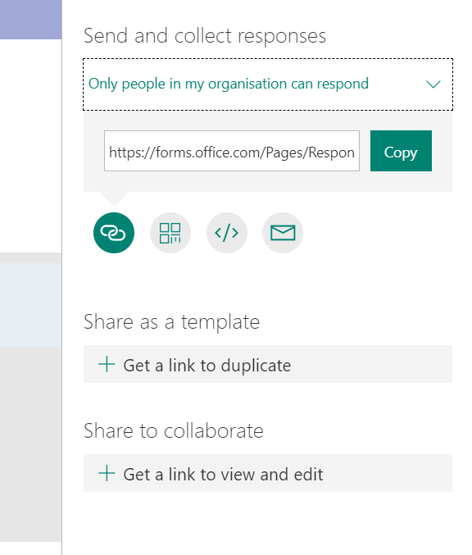

Tip Four: Reviewing the Forms’ Responses
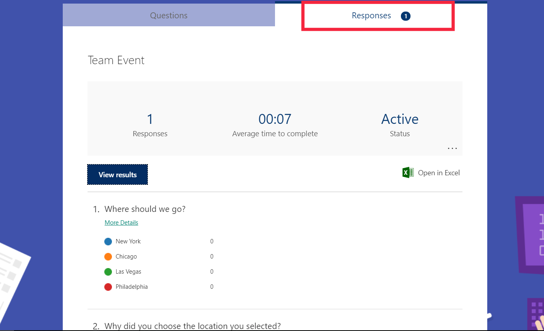
Step One: Once you have sent out the form/quiz you will be able to click on responses. Here you will see the amount of responses, the average amount of time it took to complete, what the status of the form/quiz is and all the responses that have come through.

