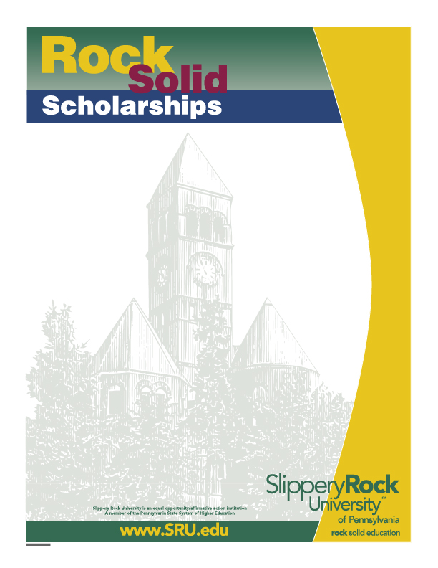

Alpha Kappa Psi Alumni Scholarship
School of Business
Applicants must be brothers in good standing with Alpha Kappa Psi business fraternity and have financial need. They must have a minimum 3.5 cumulative GPA and demonstrate leadership in community service. Preference will be given to students entering their senior year. Last year $1,500 was awarded.

Application deadline is 3:00pm February 14, 2026. Please complete and deliver the following documents to Tammie Cramer, Eisenberg Classroom Building 105:
- A completed application
- A typed letter of interest in the scholarship, including one or more paragraphs describing qualifications for this scholarship
- A current resume
- A current My Rock Audit showing the applicant’s name and GPA and credits earned

Name: ______________________________________________ Student ID#: P_____________

Undergraduate Major(s): ___________________________ Minor(s): ___________________
Overall
Are you enrolled as a full-time student? Yes/No Number of credits completed: _____ GPA: _____

Expected Graduation Date: _____________ Telephone/Cell #: __________________

Campus address: _____________________________________________________________

Home address: _______________________________________________________________

Did you complete the Free Application for Federal Student Aid (FAFSA) form for the current academic year? Yes/No

Financial Aid received for current academic year: Grants: $_________ Loans: $__________

Selection Process:
A committee consisting of elected members of the School of Business faculty will make the selection. If necessary, the Selection Committee shall request personal candidate interviews to determine the finalist for this award. Scholarship winners are required to attend the School of Business Banquet on Sunday,
April 12, 2026, at no cost to the student, and write a thank-you to the scholarship sponsor.
.

Yes, I give Slippery Rock University and the SRU Scholarship Selection Committee permission to use information contained in my academic records and on my financial aid application during the review of my eligibility for this scholarship. I understand that additional information may be requested from me for this application process.
Applicant’s Signature______________________ Date _______

