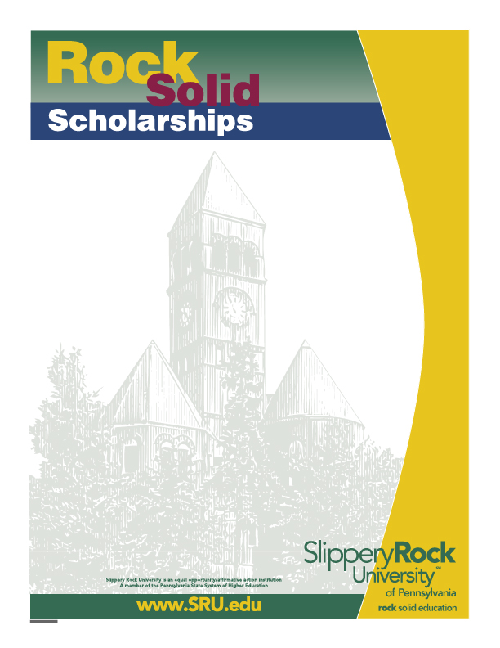

Manocha Scholarship Application School of Business
The Manocha School of Business Scholarship is established and endowed by Dr. Dineshnandini Manocha. The applicant must have an academic major within the School of Business and be enrolled full-time. They must have earned a minimum of 64 credits at SRU and have a cumulative GPA of 3.25 or higher. Financial need is also a requirement.
The award will be pursuant to the following order of preference:
Female students from an Asian country with a major in the School of Business, Students from other non-U.S. countries with a major within the School of Business, All students with a declared major within the School of Business. Scholarship amount may vary. Last year $750 was awarded.

Application deadline is 3:00 pm, February 14, 2026. Please complete and deliver the following documents to Tammie Cramer Eisenberg Classroom Building 105.
- A completed application
- A typed letter of interest in the scholarship, including one or more paragraphs describing qualifications for this scholarship
- A current resume
- Three recent letters of reference (one is required from a member of the School of Business faculty)
- A current My Rock Audit showing the applicant’s name and GPA and credits earned

Name: ______________________________________________ Student ID#: P_____________

Undergraduate Major(s): ___________________________ Minor(s): ___________________
Overall
Are you enrolled as a full-time student? Yes/No Number of credits completed: _____ GPA: _____

Expected Graduation Date: _____________ Telephone/Cell #: __________________

Campus address: _____________________________________________________________

Home address (including Country): _________________________________________________

Did you complete the Free Application for Federal Student Aid (FAFSA) form for the current academic year? Yes/No

Financial Aid received for current academic year: Grants: $_________ Loans: $__________

Selection Process:
A committee consisting of elected members of the School of Business faculty will make the selection. If necessary, the Selection Committee shall request personal candidate interviews to determine the finalist for this award. Scholarship winners are required to attend the School of Business Banquet on Sunday,
April 12, 2026, at no cost to the student, and write a thank-you to the scholarship sponsor.

Yes, I give Slippery Rock University and the SRU Scholarship Selection Committee permission to use information contained in my academic records and on my financial aid application during the review of my eligibility for this scholarship. I understand that additional information may be requested from me for this application process.
Applicant’s Signature______________________ Date _______

