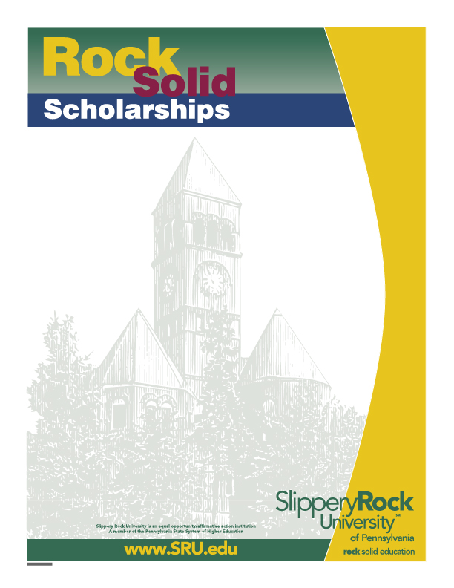

The Kenneth M. O’Toole Memorial Scholarship Application
School of Business
The Kenneth M. O’Toole Memorial Scholarship was established by Mr. and Mrs. Lawrence M. O’Toole within the Slippery Rock Foundation, Inc. The scholarship is named in memory of Kenneth M. O’Toole, a former Marketing major. It is in remembering Kenneth and his true appreciation for the numerous opportunities which he was afforded at Slippery Rock University that his parents have established the scholarship. Applicants must be a Marketing major enrolled as a full-time student and have completed a minimum of 64 credits. Applicants must have progressively improved his/her academic standing (improved GPA) at the university, be in good academic standing, and have financial need. Scholarship amount may vary.

Application deadline is 3:00pm, February 14, 2026. Please complete and deliver the following documents to Tammie Cramer, Eisenberg Classroom Building 105.
- A completed application
- A typed letter of interest in the scholarship, including one or more paragraphs describing qualifications for this scholarship
- A current resume
- A current My Rock Audit showing the applicant’s name and GPA and credits earned

Name: _________________________________________________ Student ID#: P_______________

Undergraduate Major(s): ___________________________________ Minor(s): ______________________
Overall
Are you enrolled as a full-time student? Yes/No Number of credits completed: _______ GPA: _______

Expected Graduation Date: ________________ Telephone/Cell #: ____________________

Campus address: _____________________________________________________________________

Home address: _______________________________________________________________________

Did you complete the Free Application for Federal Student Aid (FAFSA) form for the current academic year? Yes/No

Financial Aid received for current academic year: Grants: $_________ Loans: $__________

Selection Process:
A committee consisting of elected members of the School of Business faculty will make the selection. If necessary, the Selection Committee shall request personal candidate interviews to determine the finalist for this award. Scholarship winners are required to attend the School of Business Banquet on Sunday,
April 12, 2026, at no cost to the student, and write a thank-you to the scholarship sponsor.

Yes, I give Slippery Rock University and the SRU Scholarship Selection Committee permission to use information contained in my academic records and on my financial aid application during the review of my eligibility for this scholarship. I understand that additional information may be requested from me for this application process.
Applicant’s Signature______________________ Date _______

