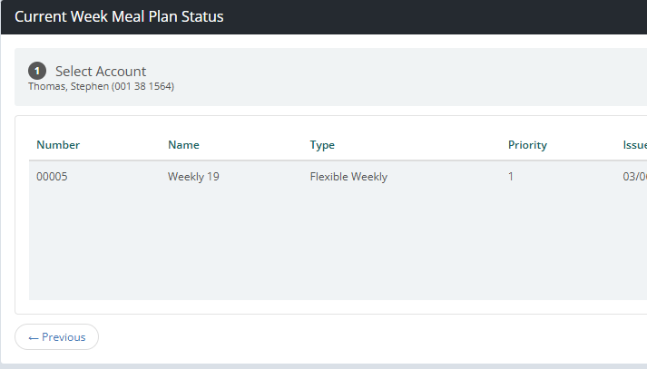

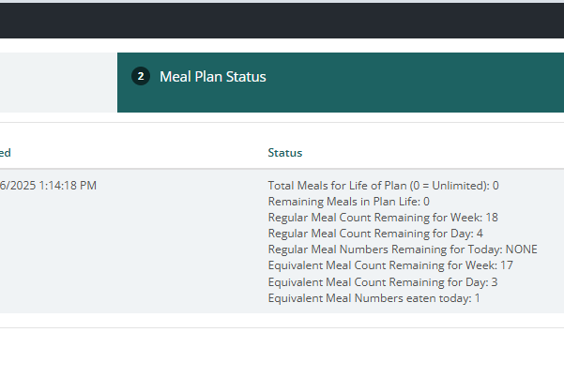

- Weekly 19 = Plan name and total number of meals per week.

- Total Meals for Life of Plan = 0 for weekly plans. Should show large number for semester plans.

- Regular Meal Count Remaining for Week = total Boozel AYCE meals remaining for the week if no equivalent meals are used. You used one meal swipe at Boozel for the week, so it’s showing 19 – 1 = 18.

- Regular Meal Count Remaining for Day = total Boozel AYCE meals remaining for the day if no equivalent meals are used. Everyone is limited to a total of 5 meals per day (regular + equivalent). You used one meal swipe at Boozel for the day, so it’s showing 5 – 1 = 4.

- Regular Meal Numbers Remaining for Today = N/A to us. This would show which meal periods are left for the day. For example: after eating breakfast (1), this would essentially show lunch (2) and dinner (3) are left.

- Equivalent Meal Count Remaining for Week = total non-Boozel AYCE meals remaining for the week if no regular meals are used. This would be total meal equivalency + meal exchange swipes used for the week. You used a meal exchange and a meal equivalency, so it’s showing 19 – 1 – 1 = 17.

- Equivalent Meal Count Remaining for Day = total non-Boozel AYCE meals remaining for the day if no regular meals are used. This would be total meal equivalency + meal exchange swipes used for the day. Everyone is limited to a total of 5 meals per day (regular + equivalent). You used a meal exchange and a meal equivalency, so it’s showing 5 – 1 – 1 = 3.

- Equivalent Meal Numbers eaten today = N/A to us. This would show how many meal periods you ate during the day. We only have one meal period for the day, so it will show 1 if you eat at least 1 meal equivalent meal that day. For example: if we had different meal periods, after eating breakfast (1), lunch (2), and dinner (3), this would show 3.

To calculate how many total meals you have left for the week:
Regular Meals Remaining + Equivalent Meals Remaining – Total Weekly Meals = Total Weekly Meals Remaining
18 + 17 – 19 = 16

