How to Add FLEX Funds
Instructions for Parents to Add Flex Funds to Student Accounts
Before you begin, you must obtain the following information from the student:
· Standard Account Number. The student can find this information by logging into MySRU, searching All Links for OneWeb, and then viewing Personal Settings.
· First name as printed on the student’s ID Card
Once you have the necessary information:
- Visit the Parents login URL.
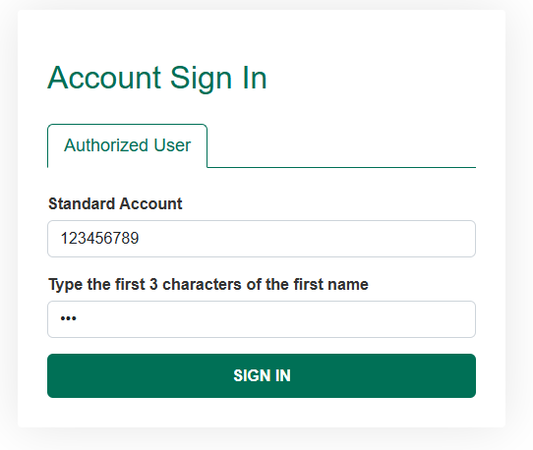
- Enter the student’s Standard Account Number.

- Enter the first three characters of the student’s first name as shown on their ID card.
- Select a balance to add funds to, if available.
- Enter the deposit amount, your email address, an optional note, and mark if you want to notify the card holder. Click continue.
- Enter the credit card information for billing purposes. Funds will be immediately available.
For any additional information or questions, please contact Dining Services at 724-738-2718, or by email at dining@sru.edu

