How to Sign Up for a Meal Plan
- Navigate to https://slipperyrock.mydininghub.com/en
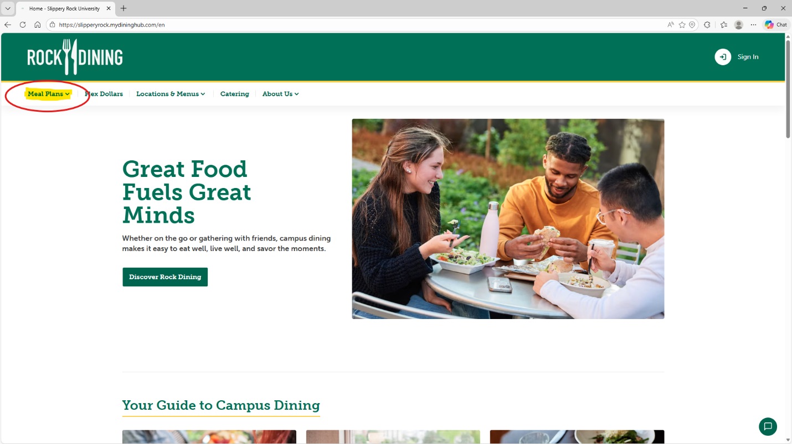
- Select “Meal Plans” from the top menu

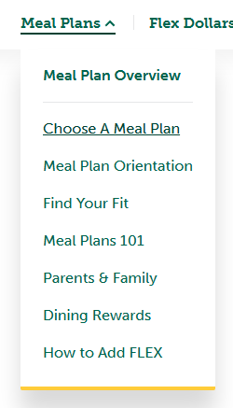
- Select “Choose A Meal Plan”
- For more information about our
meal plans, please explore the
other options in this menu.
“Find Your Fit” is a comprehensive
tool to recommend a meal plan
that best fits your campus
experience. “Meal Plans 101”
contains FAQs and tells you the
basic info about the plans we offer
at Slippery Rock University. “Parents
& Family” contains helpful information
for individuals supporting our students.

- Select a plan displayed on the webpage by clicking “Sign Up” to be taken to the ResLife portal. 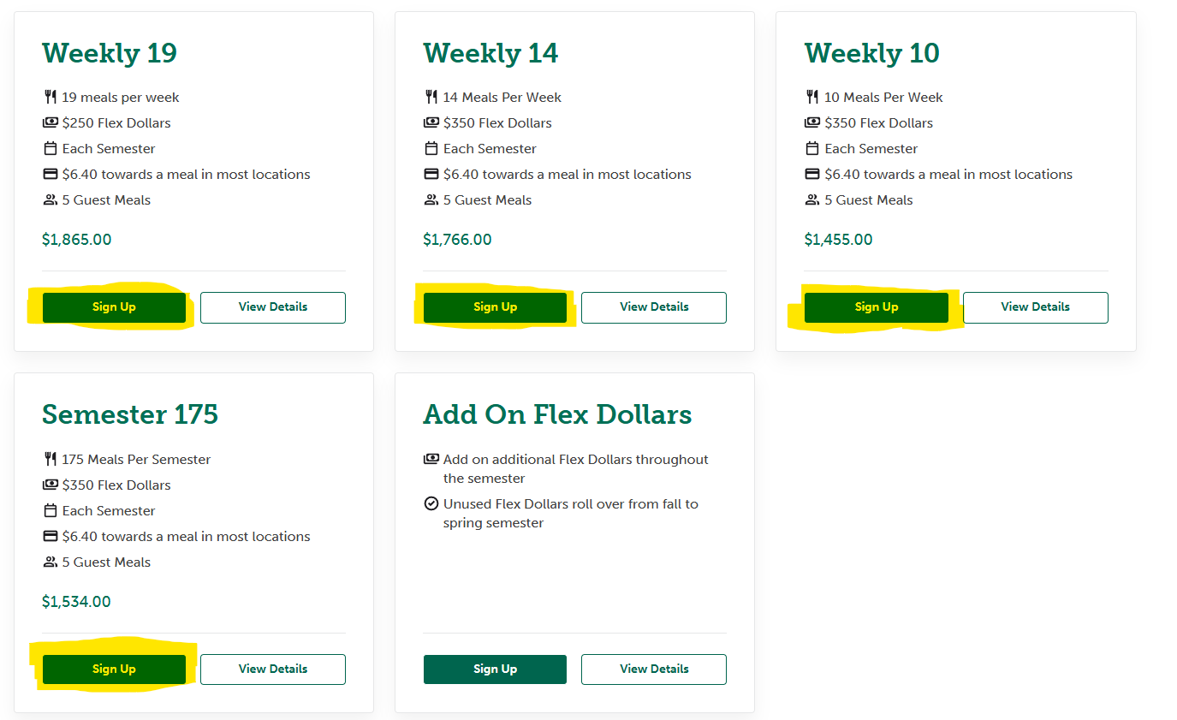

- For any additional information or questions, please contact Dining Services at 724-738-2718.

