Instructions: Assessment for the Courses in the Humanities Inquiry
Materials required to complete Assessment Plan/Reporting using the Alternative Submission process for courses in the Humanities Inquiry:
- Document - Instructions: ALT Submission Humanities Inquiry
- Course Syllabus (provided by faculty member)
- Document – ALT Submission Inq.HUM Form. Acknowledgement
- Document – Rock Studies/Liberal Studies Program Committee Approved Course Assessment plan.
- Provide Faculty Name
- List each CRN for course. This means if you teach two sections of a course – there will be 2 CRNs listed.
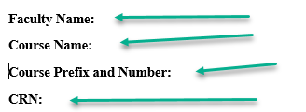

- Review the Rock Studies Program Committee approved assessment plan.
- If you are following the plan as approved complete only the GRAY box. If you are not following the approved plan (changing an assessment method/assignment type) complete the GREEN box. Complete the GRAY or the GREEN Box for each outcome – NOT BOTH.

Complete GRAY box for each outcome for which you are FOLLOWING the Rock Studies Program Committee Approved Plan.
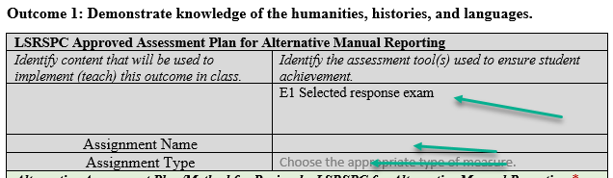
Complete GREEN box for each outcome for which you are CHANGING the assessment plan that was approved by the Rock Studies Program Committee.
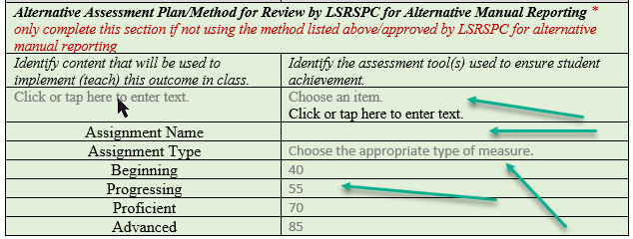
- Select the assessment tool used to ensure student achievement from drop-down box.
- Provide the name of the D2L gradebook item EXACTLY as it appears in D2L.
- Determine the score a student must demonstrate beginning, progressing, proficient, and advanced levels of achievement. If none are selected the defaults of 40, 55, 70, 85 will be used.

- Complete the l Opt-out D2L for Manual/Alternative Reporting Acknowledgement (last page of Alt. Submission Inq. HUM Form Acknowledgement.) Forms must be signed/scanned or an email sent to assessment@sru.edu from the faculty member stating that the email is a digital signature to acknowledge opting out of D2L reporting and acknowledging the use of Table 1 for reporting within three weeks of the end of the semester.
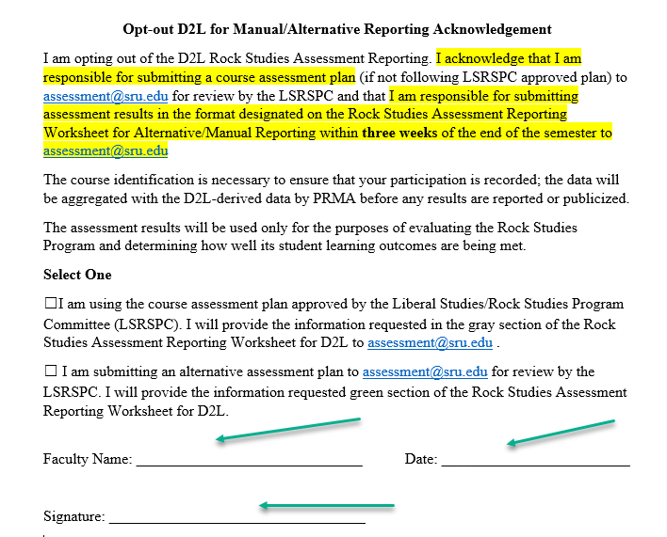
- Within three weeks of the end of the semester, provide assessment results to assessment@sru.edu, using Table 1. The required information includes, the name of the assignment, the % of students achieving each level from deficient – advanced, and the total number of students. Results can be aggregated for all sections taught or results for each section taught can be submitted separately.
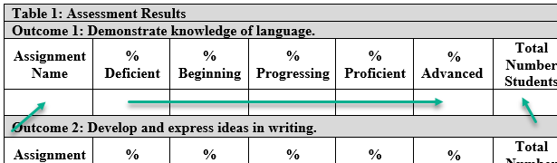

Once these forms have been completed return them to – digitally (email to assessment@sru.edu) or in hard copy (to Pam Beck 116 Patterson Hall or Samantha Kelly 117 Patterson Hall)
Documents to Return:
- Alt Submission Inq. HUM Form Acknowledgement
- Opt-out D2L for Manual/Alternative Reporting Acknowledgement.
- Table 1 Assessment Results for all outcomes.

