Instructions: Assessment for Rock Studies Inquiry Courses
Materials required to complete Assessment Plan/Reporting using D2L for Inquiry courses:
- Document - Instructions: D2 Inquiry (D2L Gradebook Access)
- Course Syllabus (provided by faculty member)
- Document – D2L Assessment Inq.SocSciForm.Permission
- Document – Rock Studies/Liberal Studies Program Committee Approved Course Assessment plan.
- Provide Faculty Name
- List each CRN for course. This means if you teach two sections of POLS 220 – there will be 2 CRNs listed.
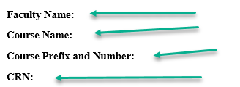

- Review the Rock Studies Program Committee approved assessment plan.
- If you are following the plan as approved complete only the GRAY box. If you are not following the approved plan (changing an assessment method/assignment type) complete the GREEN box. Complete the GRAY or the GREEN Box for each outcome – NOT BOTH.

Complete GRAY box for each outcome for which you are FOLLOWING the Rock Studies Program Committee Approved Plan.
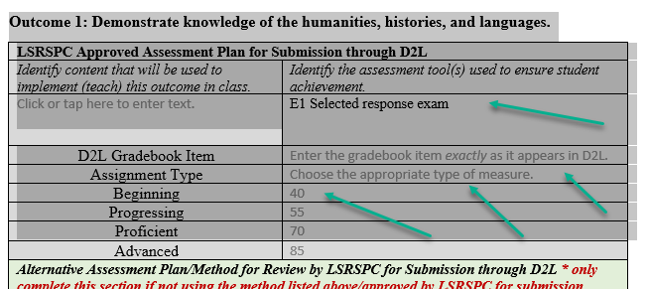
Complete GREEN box for each outcome for which you are CHANGING the assessment plan that was approved by the Rock Studies Program Committee.
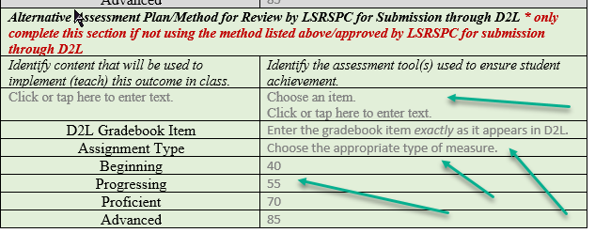
- Select the assessment tool used to ensure student achievement from drop-down box.
- Provide the name of the D2L gradebook item EXACTLY as it appears in D2L.
- Determine the score a student must demonstrate beginning, progressing, proficient, and advanced levels of achievement. If none are selected the defaults of 40, 55, 70, 85 will be used.
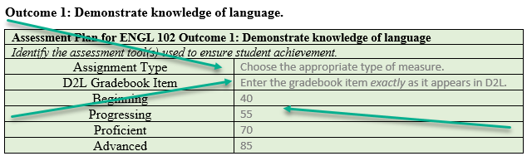
- Complete the Permission to Access D2L Gradebook. (Last page of D2L Assessent.Inq.Form. Permission.) Forms must be signed or an email must be sent to assessment@sru.edu from the faculty member stating that the email is a digital signature allowing permission to access the D2L gradebook – without a signed form or an email for a digital signature the data will NOT be collected.
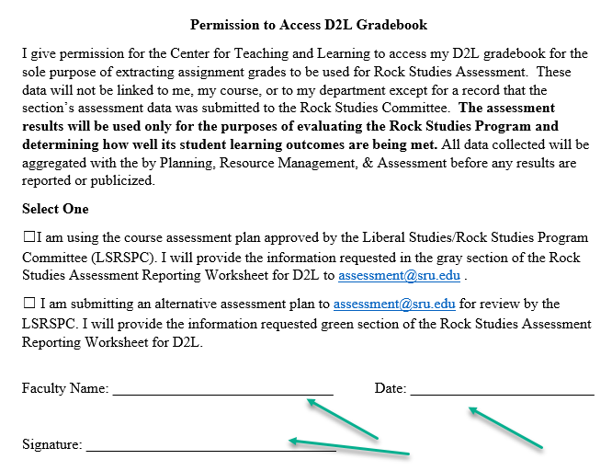
Once these forms have been completed return them to – digitally (email to assessment@sru.edu) or in hard copy (to Pamela Beck 116 Patterson Hall or Samantha Kelly 117 Patterson Hall)
Documents to Return:
- D2L SSInq.Form.Permission
- Permission to Access D2L Gradebook

AND THAT IS IT.
There is NOTHING to do in D2L, no other forms to complete – your work is finished for this semester.

