
Staff 2026/2027 Parking Permits

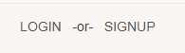
- Navigate to our parking portal. Select “LOGIN -or- SIGNUP” in the top right corner, then “Affiliated Login” on the next page. Sign in with your SRU email address and password.
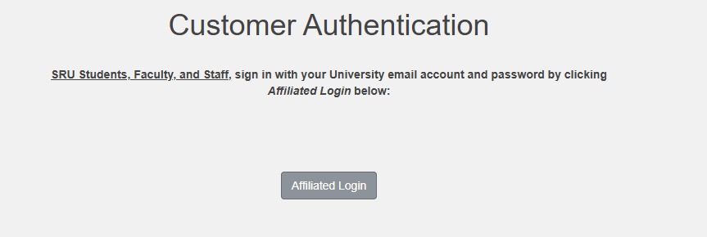

- On the top menu, select “PERMITS”, and “Get Permits”. 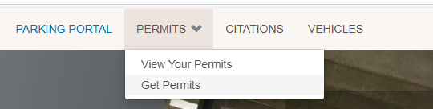
- Enter/confirm your address information, and hit next. It will ask for your confirmation a second time, then hit next again.

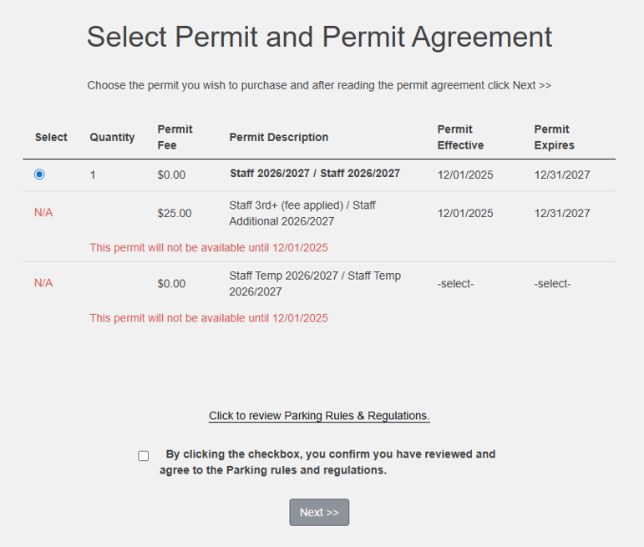
- Select “Staff 2026/2027” permit from the list. Once you have reviewed SRU’s Parking Rules and Regulations, check the box and click “Next”.

- Select the vehicle you would like to attach to the permit (Or use the “Add Vehicle” option to add a new one), and click “Next”. 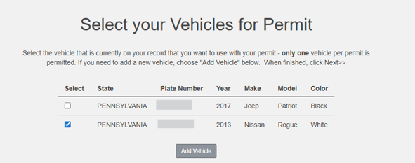

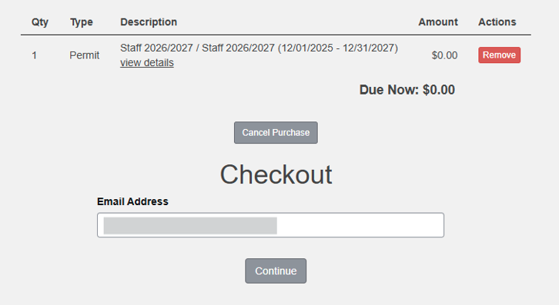
- This will add the permit to your cart. To proceed, select “Continue” to advance to the Payment Information screen. You will see “Due Now: $0.00”. Select “Pay Now” to process the permit, and print the receipt for your records.

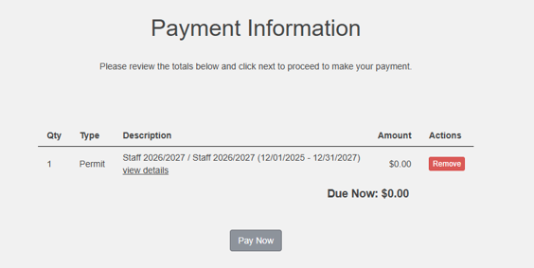
To add a second vehicle, navigate back to the top menu, select “PERMITS” and “Get Permits” and repeat the steps.

If you have any problems, questions, or concerns, please reach out to the Parking and ID Office (Campus Success Center 203) at 724-738-4785 or by email at sruparking_id@sru.edu.

