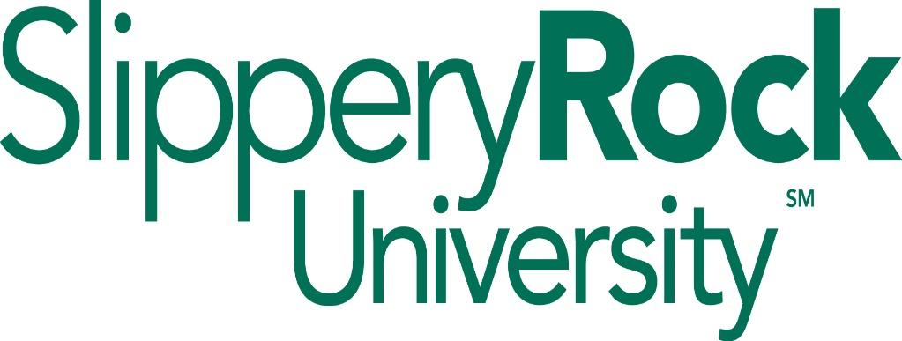

**Recycling Program**

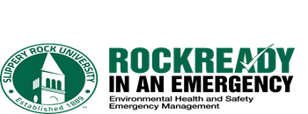

January 1, 2013 (Revised August 2023)

Background

Beginning in the late 1980s, Slippery Rock University put forth an initiative referred to as the campus recycling project. A collaborative campus recycling program was initiated involving the Department of Environmental Health and Safety (EHS) and Facilities & Planning that focused on collecting basic recyclable materials including paper, cans, bottles and glass.

Since those days, technologies have improved and new technologies have been developed to recycle a substantially broader spectrum of products that keeps these items out of solid waste landfills. Furthermore, the federal Environmental Protection Agency (EPA) issued amended legislation that permitted recycling of materials that otherwise would need to be processed as hazardous waste, creating new recycling opportunities as universal waste. Common examples of universal waste include used fluorescent lamps and ballasts, certain types of batteries, tires and metallic components of electronic devices such as PCs, laptops, old TVs and computer screens. Certificates of recycling are provided by our service suppliers.

Recycling at SRU is part of overall sustainability efforts on campus. EHS partners with the President’s Commission on Sustainability to promote green initiatives on campus.

Recycling Procedures

1. General Recyclables
2. Aluminum Cans, Plastic Bottles and Glass Containers

Bins labeled for aluminum cans, plastic bottles and glass containers have been placed throughout the campus. The containers are designated for these materials only – never place paper or ordinary trash in these containers. The bins will be removed nightly by Facilities custodial staff to a designated location, usually near loading docks of the buildings. Materials will be picked up and removed from campus by a contracted supplier approximately every two (2) weeks depending on volume.

1. Cardboard

In order to be recycled, cardboard boxes must be “clean” – meaning free of gross dirt, grime and gravel - and must be broken down and taken a designated area in the building and placed in carts. When full, the carts of cardboard will be transported and delivered to the Stores II Building for baling. A contracted supplier will remove the baled cardboard from campus approximately every two (2) weeks depending on volume.

The only exception to this process occurs with respect to the Student Center, where the cardboard is taken directly to a baler on the 2nd floor. The cardboard is baled on-site by Student Center personnel and stored in a designated area for pick up and removal from campus a contracted supplier approximately every two (2) weeks depending on volume.

1. Paper (Confidential)

In order to securely dispose of confidential documents, SRU contracts with supplier that performs on-site shredding services. This supplier provides collection bins which are permanently located in select areas of campus based on volume. Collection bins for temporary one-time large confidential document shredding can be requested by contacting Environmental Health & Safety/Emergency management at 724-738-2055.

Once shredded, the paper remnants are removed and recycled.

1. Paper (Non-Confidential)

Regular paper and newspapers are to be placed in bins labeled PAPER and located in campus buildings across campus. The bins will be removed Facilities custodial staff to a designated location, usually near loading docks of the buildings. Paper materials are picked by a contracted supplier and removed from campus approximately every two (2) weeks.

1. Universal Waste

**NOTE: ENVIRONMENAL REGULATIONS PROHIBIT THIS EQUIPMENT FROM DISPOSAL AS ORDINARY TRASH.** The equipment and materials identified below contain metals that can leech out and contaminate water supplies if not managed properly.

Disposal of the following materials is regulated under the hazardous waste regulations of the federal Environmental Protection Agency and enforced in the Commonwealth of PA by the Department of Environmental Protection (DEP). These materials cannot be discarded in regular solid waste streams (trash or garbage containers): used lamps (fluorescent light bulbs, non-PCB ballasts, non-alkaline batteries and electronic waste i.e. computers, monitors, copiers, etc…)

Because these materials are submitted for recycling, they are permitted to be labeled and processed as “universal waste”.

1. Lamps & Ballasts

Used lamps (fluorescent bulbs) contain mercury and are removed by Facilities maintenance personnel. Even used fluorescent lamps labeled as “green-tip” still contain mercury just at lower levels. Unless testing is performed to validate mercury concentrations are below regulatory levels, the green tip bulbs must be managed as universal waste.

Electrical ballasts are devices contained in fluorescent light fixtures and are designed to limit the amount of current in an electric circuit. Older light fixtures were manufactured with ballasts containing polychlorinated biphenyls (PCBs). PCB ballasts must be managed as hazardous waste and are strictly regulated by the EPA and the DEP. However, non-PCB ballasts may be managed as universal waste.

These materials are brought to a central collection area in Stores 2 building for storage and processing. The materials are removed from campus by a contracted supplier licensed to handle, transport and recycle universal waste approximately at least every twelve (12) months, per DEP regulations.

1. Batteries

Acceptable batteries for recycling include rechargeable batteries (nickel-cadmium, lithium ion, and metal-hydride batteries from cell phones, PDA’s and other small portable electronic equipment).

Prior to discarding any batteries, please place a small piece of tape over the battery contacts. If battery terminals touch they can spark and create a fire hazard.

Larger lead-acid batteries from vehicles, heavy power equipment, etc… are returned to the seller for recycling and exchanged for a new battery.

Rechargeable batteries are stored and removal approximately every six (6) months by a licensed universal waste recycling supplier.

Alkaline batteries (AA, AAA, C, etc…) are not considered hazardous waste and may be discarded in ordinary trash containers.

1. Computers & Electronics

Unwanted technology equipment deemed waste (computers including laptops, keyboards, monitors, printers, fax machines etc…) is submitted to Administrative Information and Technology Systems (IATS). IATS rotates equipment and may re-issue to another campus user where feasible. Electronic equipment that is deemed waste is delivered to Central Receiving in the Stores I Building. EHS/EM facilitates removal and destruction by a licensed universal waste recycling supplier.

1. Miscellaneous Recyclable Materials
2. Tires – all tires from campus vehicles are collected and stored in a central location. Periodically but at least once annually they are picked up by a licensed tire recycling supplier.
3. Scrap Metal – all scrap metal is collected and stored in a central location at fenced in location on the outer edge of campus. Periodically, but at least annually they are transported to a licensed scrap metal recycler.
4. Toner Cartridges – all toner cartridges from laser printers and copiers should be placed in the box the new toner cartridges were taken from and sent via campus mail to Central Receiving. Periodically but at least once annually they are picked up by a licensed recycling supplier.
5. Wood Pallets – wood pallets are stored in an area outside the Central Receiving area of the Stores I Building. They are reused by Central Receiving and EHS/EM personnel as part of departmental operations.
6. Food Scraps – food scraps from the dining halls are taken by the Macoskey Center staff for purposes of reuse on an as-needed basis

Revised August 2023